Course: | BF10: Principles of Business and Finance
Objective: | NC CTE 1.03: Write internal and external business correspondence to convey and obtain information effectively. (CO:016) (CO:088) (CO:089) (CO:090)

1.03A- Five C's of Business Writing

A good business letter is always written with the reader in mind. The writer considers:
Who will be reading the letter?
What is the purpose or objective in writing to this person or group (to inform, to persuade, or to instruct)?
What is important to this reader?
What do you expect the reader to do in response to this memo or report?

Knowing the 5 Cs of business writing can help you write effectively. Your correspondence should be:
• Clear: Make sure your purpose and intent is clear to the reader. Understand your audience.
• Concise: Make sure are not too wordy. Keep all communication concise and to the point
• Courteous: Address the reader politely. Use expressions such as: “please and thank you”.
• Complete: Include all the information the reader needs to have.
• Correct: Edit and proofread so that it has no grammar, spelling and punctuation error.
Directions:
1. The letter below does not follow the 5Cs of business writing. With a partner, discuss the faults and suggestions of improvement to the letter based on the questions.
1. Is the opening statement clear? If not, how would you change it so that it is clear?
2. Is the information complete? If not, what is missing?
3. Are the sentences concise? If not, what words would you eliminate to make them more concise?
4. Is the message courteous? If not, which sentence would you change?
5. Is the letter correct (free of grammar, punctuation and spelling errors)? If not, what should be corrected?
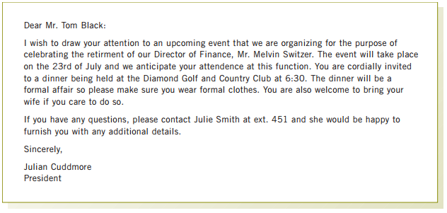

2. Working independently, use MS Word to rewrite the letter above so that it is clear and concise, complete and correct.

1.03 B-Choosing the Right Communication

Directions:
- Look at the scenarios below. Selecting from the choices of communication methods (A) through (E), decide on the most appropriate way(s) of communicating the message. In some cases, more than one method of communication may be appropriate.
- by memo
- by letter
- in person
- by email
- by phone

Method(s) | Scenarios
 | The personnel manager wants to inform all staff that there have been changes to the company benefits package. Staff can find information about the changes on the company website.
 | The Human Resources department wants to inform the staff that the company is offering free English as a Second Language classes three times a week during the lunch hour.
 | The administrative assistant needs to arrange a meeting between a client and two members of the design department.
 | The manager is going to a conference in another city. She would like her assistant to book the flight and hotel.
 | There is a new company policy. No one is allowed use of the internet, cell phones or other electronic devices for personal reasons while on duty.
 | The accounts receivable clerk has not received payment from a customer. The invoice is now 90 days overdue.
 | An employee wants to invite co-workers to a surprise luncheon for their supervisors’ birthday.
 | Some staff members have been leaving dirty dishes in the lunchroom. The administrative assistant wants to remind everyone to clean up after themselves.
 | An employee would like to request a three-month leave of absence to take care of a family member who is very ill.
 | The personnel manager wants to inform a staff member that she will be receiving a pay increase effective next month.

- Using the business documents templates on the next page; provide one example of a professional Memo, Email, and Letter, using any of the scenarios above. (You can use real or fictitious names of people, places, products and companies).

Email Message
From: | Cc:
To: | BCC:
Subject: | Attachment:

Memorandum
From:
To:
Subject:

Business Letter

1.03B-Business Documents Rubrics

Use the following rubric as a guide in completing your business documents

Email
 | Content | Format
To (10 maximum points)
From (10 maximum points)
Subject (10 maximum points)
Attachment (15 maximum points)
Cc (10 maximum points)
Body (30 maximum points)
Signature (15 maximum points)
Total Maximum Points - 100

Memorandum
 | Content | Format
Date (10 maximum points)
To (10 maximum points)
From (10maximum points)
Subject (10 maximum points)
Body (60 maximum points)
Total Maximum Points - 100

Letter
 | Content | Format
Letterhead (10 maximum points)
Date (4 maximum points)
Inside Address (10maximum points)
Salutation (10 maximum points)
Title/ Reference Line (6 maximum points)
Introductory Paragraph (10 maximum points)
Body (20 maximum points)
Closing Line/Paragraph (10 maximum points)
Signature Line (6 maximum points)
Complimentary Closing (6 maximum points)
Enclosure Notation (4 maximum points)
Copy Notation (4 maximum points)
Total Maximum Points - 100

1.03C-Correcting a Business Letter

Directions:
The letter below has seven errors in the use of verb tenses. Using MS Word, Review feature-Track Changes to make/offer changes. If you are unfamiliar with the MS Word, Track Changes, you can underline the errors and type your suggested corrections beside the error in parenthesis.

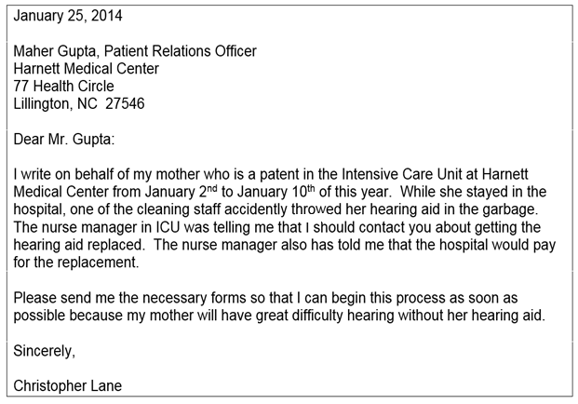

Adapted from Chapter 2 of the LINC 5-7 Classroom Activities, Business Writing Volume 2

1.03D- Exchanging Emails

Instructions: Read the steps below and exchange emails with a partner. Each student will forward to your teacher via email, the final/full string of dialog from your email correspondence. You will be graded based on your individual contributions to the dialog. You and your partner will work on the same step of the process at the same time. One team member will start the email exchange for step 1 and alternate responses for the remaining steps with their partner.

Step 1
You are working with your partner on a project for this class. You think you may need more information to move forward on the project, so you want to meet. Write an email suggesting a meeting. Include a possible time and place to meet, and mention the topic you want to discuss. Exchange emails.

Step 2
Respond to your partner’s email. Agree to meet, but suggest another time. Give a reason. Exchange emails.

Step 3
Respond to your partner’s email. Give the reason why you are not available at the suggested time. Propose an alternative time to the one your partner suggested. Exchange emails.

Step 4
Agree to the new meeting arrangements. Offer to bring something (i.e. snacks, coffee or some sweets). Exchange emails.

Step 5
Respond to your partner’s email. Confirm the arrangement.

Submit the final email thread to the teacher per teacher’s instructions.

