MOAC Access Lesson 1 Overview

STEP BY STEP L1-1 Start Access in Windows 7

GET READY. Before you begin these steps, be sure to turn on and/or log on to your computer.
- When starting Windows 7, on the Windows taskbar, click the Start button and then click All Programs. A menu of installed programs appears.
- Click Microsoft Office. Another menu appears.
- Click Microsoft Access 2013. The Access startup screen opens, as shown in MOAC page 5 Figure 1-5.

- PAUSE. LEAVE Microsoft Access open to use in the next exercise.

Opening an Existing Database
When you open an existing database, you access not only your previously entered and saved data, but the elements you created to organize that data. In this exercise, you open a database that is in the beginning stages of development. Whether you browse for fi les using services such as SkyDrive or Office 365, or browse for files using the Computer command, you must use the Browse button to access the Open dialog box.

STEP BY STEP L1-2 Open an Existing Database
GET READY. The Access startup screen should be on the screen from the previous exercise.
- Click the Open Other Files command on the left side
- Navigate to the data fi les for this lesson and select Student Information.
- Click the Open button in the Open dialog box (see Figure 1-7 below). The existing database opens, as shown in MOAC Lesson 1 page 7 - Figure 1-8.

- Another way to display the Open screen is to type Crtl + O.

- PAUSE. LEAVE Microsoft Access open to use in the next exercise.

Clicking the Open button opens the database for shared access in a multi-user environment so that you and other users can read and write to the database. If you click the down arrow next to the Open button, as shown in Figure 1-9 below, other options are available on the menu:
- Open: Opens with default access.
- Open Read-Only: Opens with only viewing ability and not editing ability. Others can still read and write.
- Open Exclusive: Opens so that the database is only available to you. Others will receive a message that the fi le is already in use.
- Open Exclusive Read-Only: Opens with only viewing ability and not editing ability. Others can only view and not edit the database.

Using the Navigation Pane
Before you can create a database, you need to understand its most basic elements. This section introduces you to some of the elements in a database that help you organize data and navigate using the Navigation Pane, object tabs, and different views.

STEP BY STEP L1-3 Use the Navigation Pane
USE the database from the previous exercise.
- In the Navigation Pane, double-click Students to display the table in the Access work area, as shown in MOAC Lesson 1, page 10 - Figure 1-11.
- Click the down arrow next to All Access Objects at the top of the Navigation Pane to display the menu, as shown in MOAC Lesson 1, page 11 - Figure 1-12.
- Click Tables and Related Views. The default group in this category is All Tables, which appears in the menu at the top of the Navigation Pane. Notice the Students table and all other objects related to it are displayed under the Students header
- Click the down arrow next to All Tables at the top of the Navigation Pane to display the menu again, and click Object Type to return to the original view.
- Right-click in the white area of the Navigation Pane to display a shortcut menu. Click View By and then choose Details, as shown in Figure 1-13 below.
- The database objects are displayed with details. Click the right side of the Navigation Pane and drag to make it wider so all the information can be read, as shown in Figure 1-14 in the MOAC page 13.
- If the search bar does not appear at the top of the Navigation Pane, right-click the All Access Objects header of the Navigation Pane. On the shortcut menu, click Search Bar. A search bar is now displayed at the top of the Navigation Pane. You can toggle the search bar display by clicking the Search Bar option.
- Display the Navigation Pane shortcut menu, click View By, and then click List to display the database objects in a list again.
- Click the Shutter Bar Open/Close Button to collapse the Navigation Pane. Notice it is not entirely hidden, as shown in Figure 1-15 in the MOAC, page 14.
- Click the Shutter Bar Open/Close Button to expand the Navigation Pane again.

- PAUSE. LEAVE Microsoft Access open to use in the next exercise.

STEP BY STEP L1-4 Use Object Tabs
USE the database you used in the previous exercise.
- In the Navigation Pane, double-click.
- In the Navigation Pane, double-click All Students. A new object tab opens to display the report, as shown in Figure 1-17 in the MOAC page 15.
- Click the Close button on the report tab to close it.
- Right-click the Student Details tab to display the shortcut menu shown in Figure 1-18 in the MOAC page 16.
- Click Close to close the form.

- PAUSE. LEAVE Microsoft Access open to use in the next exercise.

Another Way to Change Views
You can also change an open object’s view by clicking on the top half of the object’s View button, by right-clicking on an open object’s window tab, or by right-clicking on the object in the Navigation Pane and choosing the desired view from the shortcut menu that appears regardless of whether the object is open or closed.

STEP BY STEP L1-5 Change Views
USE the database you used in the previous exercise. The Students table should be displayed in the Access work area.
- On the HOME tab, in the Views group, click the down arrow on the View button to display the menu shown in Figure 1-19 in MOAC on page 17.
- Click Design View. The table is displayed in Design View, as shown in Figure 1-20 in the MOAC page 17. Notice that the DESIGN tab is now displayed on the Ribbon.
- On the DESIGN tab, in the Views group, click the down arrow on the View button, and then click Datasheet View.
- On the Ribbon, under the TABLE TOOLS tab, click the FIELDS tab to display the contextual commands for that view, as shown in Figure 1-21 in the MOAC on page 18.

- PAUSE. LEAVE Microsoft Access open to use in the next exercise.

STEP BY STEP L1-6 Use the Ribbon
USE the database you used in the previous exercise.
- Click the HOME tab to make it active. As shown in Figure 1-22 in the MOAC page 19, the Ribbon is divided into groups of commands. Notice the dialog box launcher in the lower-right corner of the Clipboard group.
- Click the CREATE tab to make it the active tab. Notice that the groups of commands change.
- Click External Data and then Database Tools to see the commands available on those tabs.
- Click the HOME tab.
- Click the ID column header in the table to select the ID column.
- Click the dialog box launcher in the lower-right corner of the Text Formatting group. The Datasheet Formatting dialog box appears, as shown in Figure 1-23 in the MOAC on page 19.
- Click Cancel to close the dialog box.
- Double-click the HOME tab. Notice the groups are hidden to give you more screen space to work with your database.
- Double-click HOME again to display the groups.

- PAUSE. LEAVE Microsoft Access open to use in the next exercise.

The Quick Access Toolbar located by default at the top-left corner of the Access screen contains the commands that you use most often, such as Save, Undo, and Redo. The Touch/Mouse Mode command also exists on this toolbar, which allows you to select either touch or mouse mode.

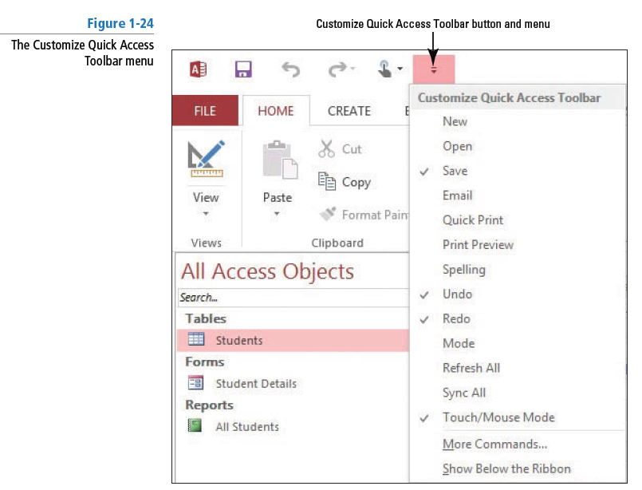

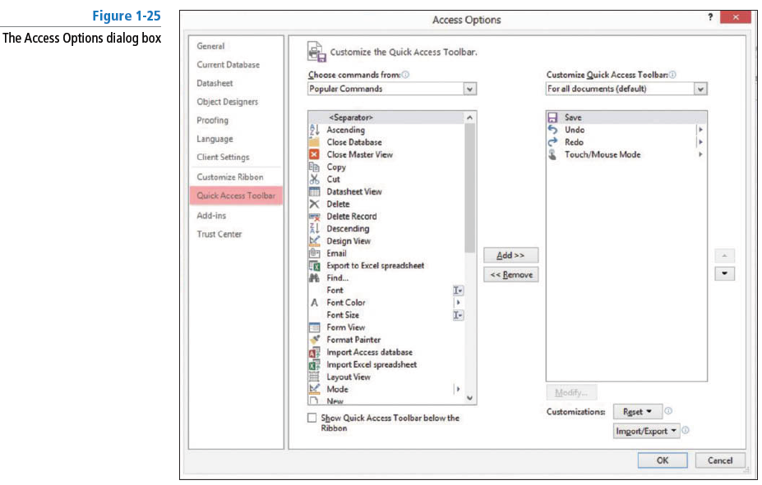

STEP BY STEP L1-7 Use the Customize Quick Access Toolbar Menu
USE the database you used in the previous exercise.
- On the Quick Access Toolbar, c lick the Customize Quick Access Toolbar button. A menu appears.
- Click Show Below the Ribbon. The toolbar is moved.
- Click the Customize Quick Access Toolbar button again. Click Show Above the Ribbon.

- PAUSE. LEAVE Microsoft Access open to use in the next exercise.

When you press the ALT key, small letters and numbers called KeyTips appear on the Ribbon in small square labels, called badges. To execute a command using KeyTips, press the ALT key then press the KeyTip or sequence of KeyTips that corresponds to the command you want to use. Every command on the Ribbon has a KeyTip. You learn to display KeyTips in the next exercise.

STEP BY STEP L1-8 Use KeyTips
USE the database you used in the previous exercise.
- Press ALT. Letters and numbers appear on the Ribbon to let you know which key to use to access commands or tabs. See Figure 1-26 below.
- Press C to activate the CREATE tab.
- Press P to display the Application Parts menu.
Note: You learn more about Application Parts in Lessons 2 and 10.
- Press ALT to remove the KeyTips.

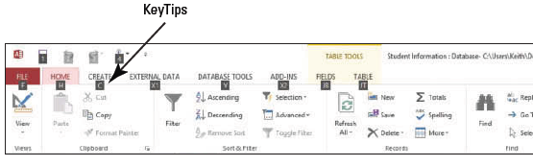

Shortcut keys are keys or combinations of keys pressed together to perform a command. Shortcut keys provide a quick way to execute commands without having to move your hands off the keyboard and reach for a mouse. Keyboard shortcuts from previous versions of Access that begin with CTRL are the same. However, those that begin with ALT are different and require the use of KeyTips.

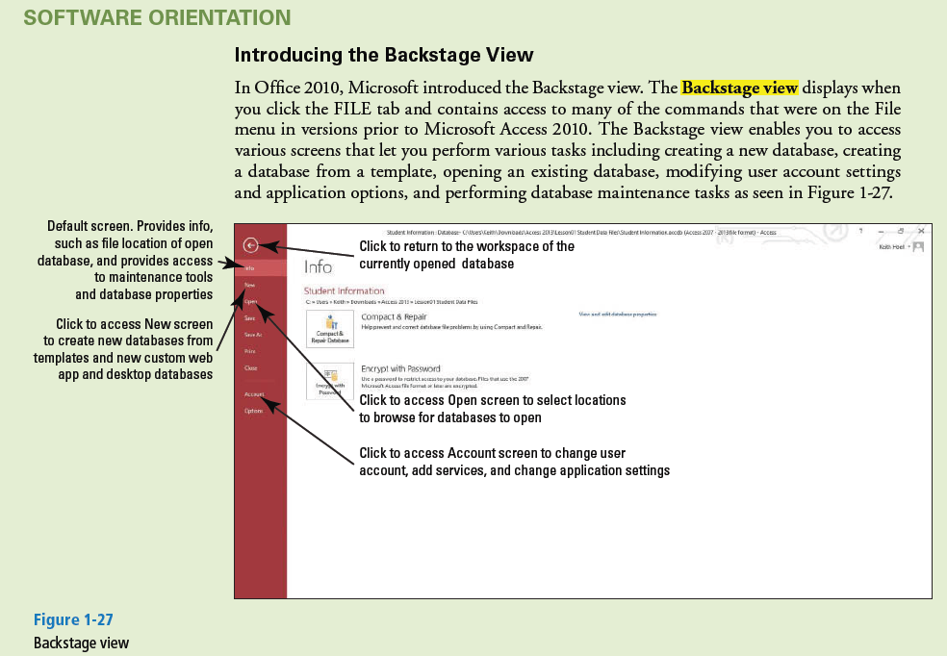

The FILE tab on the Ribbon accesses the Backstage view—a menu of options and commands that allows you to access various screens to perform common tasks with your database files—such as opening, saving, printing, closing, and changing user account settings and options. It also contains additional commands for managing your database.

The following is an overview of the options in the Backstage view:
- Info: Default view. Use this option to view the current database fi le path and view and edit database properties. Compact and repair the database and encrypt the database with a password to restrict access.
- New: Use this option to create a new database from scratch or from available templates.
- Open: Use this option to open an existing database and view a list of recently accessed databases.
- Save: Use this option to return to the open database window where objects can be saved.
- Save As: Use this option to save the current database object (such as a table, query, form, or report) as a new object or save the database in another format that is compatible with earlier versions of Access. You can save the database to a document management server for sharing or you can package the database and apply a digital signature. You can also back up the database.
- Print: Use this option to quick-print straight to the printer, open a dialog box from which to choose print options, or preview your document before printing.
- Close: Use this option to close the open database but keep the Access application open.
- Account: Use this option to view and modify user account settings. Change application background and theme. Add a service and activate Access with a product key.
- Options: Use this option to customize language settings, display settings, and other settings.

STEP BY STEP L1-9 Use the Backstage View
USE the database you used in the previous exercise.
- Click the FILE tab. Backstage view opens, displaying a menu of options down the left side of the window and information about the currently opened database, as shown in Figure 1-28.
- Click the New option to view the options and commands available.
- Click the Save As option to view more options and commands.
- Click the Back button to exit the menu and return to the Access workspace.

- PAUSE. LEAVE Microsoft Access open to use in the next exercise.

Using the Help Button and Change Help Collection Menu
The Change Help Collection menu in the lower-right corner of the Access Help heading lets you choose between the help topics that are available online and the help topics installed in your computer offline.

STEP BY STEP L1 -10 Use the Help Button and Change Help Collection Menu
- NOTE: When you rest the mouse pointer over a command on the Ribbon, a ScreenTip displays the name of the command. Access 2013 also has Enhanced ScreenTips, which provide you with more information about the command.

USE the database you used in the previous exercise.

- Click the Microsoft Access Help button, as shown in Figure 1-29 in the MOAC on page 25. The Access Help dialog box appears, as shown in Figure 1- 30 in the MOAC on page 25. Notice the Search box and Search button. Also notice the Change Help Collection button; after selecting it, an option is set to Access Help from Office.com to search online for help topics. If the Change Help Collection is set to Access Help from your computer, the screen will look different.
- Click the Change Help Collection button. A menu appears, as shown in Figure 1-31 below.
- Click Access Help from your computer. Basic Help appears, as shown in Figure 1-32 in the MOAC on page 26.
- In the Search help text box, key font and then click the Search button. A list of possible locations on the Ribbon where fonts can be manipulated appears.
- In the search results that appear, click the Font is under Home/Text Formatting link. Help on this topic appears.
- Click the Keep Help on Top button. The Access Help dialog box is now pinned to the front of the window so it is always on top and easily referred and not hidden even if another screen element is clicked.
- Click the Back button. The search results for font appear again.
- Click the Home button. The home page of Access Help appears.
- Click the Change Help Collection button.
- Click Access Help from Office.com to reset the help Collection.
- Click the Close button to close Access Help.
- Choose FILE and then click Close to CLOSE the database without closing Access.

- NOTE: you can hit F1 to get the help menu as well.
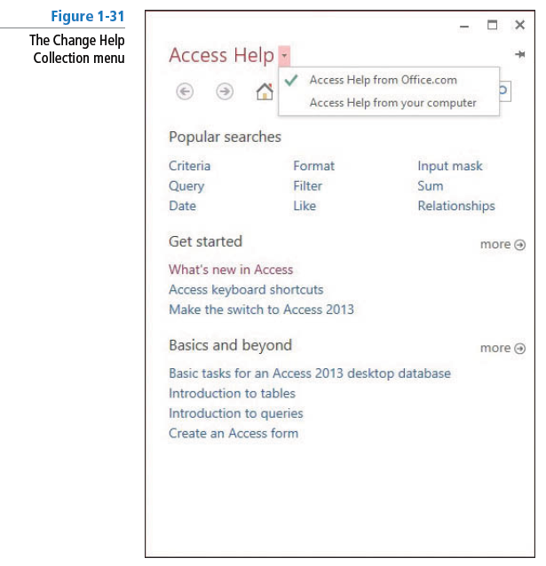

- PAUSE. LEAVE Microsoft Access open to use in the next exercise.

DEFINING DATA NEEDS AND TYPES (Make sure you read this)
To create a database that achieves your goals and provides you with up-to-date, accurate information you need to spend time planning and designing it. When planning a database, the first step is to consider the purpose of your database. You need to design the database so that it accommodates all your data-processing and reporting needs. You should gather and organize all the information that you want to include, starting with any existing forms or lists, and think about the reports and mailings you might want to create using the data.

Once you have decided how the information will be used, the next step is to categorize the information by dividing it into subjects such as Products or Orders, which become the tables in your database. Each table should only contain information that relates to that subject. If you find yourself adding extra information, create a new table.

In a database table, data is stored in rows and columns—similar in appearance to a spreadsheet.
Each row in a table is called a record. Each column in a table is called a field. For example, if a table is named “Student List,” each record (row) contains information about a different student and each field (column) contains a different type of information about a student, such as last name or email address.

Once you have decided to create a Student List table, you need to determine what information you want to store in the table—such as Age, Birthdate, or Tuition. Organize each piece of information into the smallest useful part—for example, use First Name and Last Name instead of just Name if you want to sort, search, calculate, or report using either a first name or a last name (or both).
These pieces of information will eventually become your fields (columns), and each record (row) will then contain complete information about each student.

For each table, you will choose a primary key. A primary key is a column that uniquely identifies each row, such as Student ID Number. In the case of our Student List table, the primary key (Student ID Number) uniquely identifies each student.

STEP BY STEP L1-11 Review Database Fields
OPEN the Student Data database from the data fi les for this lesson.

- On the Student List form, click the ID for record 5 to display the Student Details dialog box for Sharon Hoepf, as shown in Figure 1- 33.
- Click the Guardian Information tab and then the Emergency Information tab. Each field on each tab is an example of the type of information that could be contained in a database table.
- Click Close to close the Student Details dialog box.

- PAUSE. LEAVE Microsoft Access open to use in the next exercise.

Defining and Modifying Data Types for Fields
When defining table fields, it is important to define them as specifically as possible. For example, if you are using a number, you should determine whether you need to use the Currency data type, the Calculated data type, or the Number data type.

There are two data types new to Access 2013: Short Text and Long Text. The Short Text data type replaces the Text data type used in previous versions of Access; the Long Text data type replaces the Memo data type. The Short Text data type is used to store up to 255 characters of data in a field and is a good data type for a field that stores small amounts of text, such as names, cities, and states. To store data greater than 255 characters, you can use the Long Text data type. The
Long Text data type can display up to 64,000 characters on the screen, but can store about one gigabyte of text. This data type can be used for a field that contains large amounts of text, like customer comments.

STEP BY STEP L1-12 Review and Modify Data Types for Fields

USE the database you used in the previous exercise.

- Close the Student List form.
- In the Navigation Pane, in the Students group, double-click the Students table to open it.
- Click the Date of Birth field header.
- On the Ribbon, click the FIELDS tab. Notice in the Formatting group that the Data Type is Date/Time.
- In the Format box , c lick the down arrow to display the menu of formatting options for that type, as shown in Figure 1- 34 in the MOAC on page 29.
- Click the Last Name header. Notice that the Data Type is Short Text and that no formatting options are available for that data type.
- Scroll to the right and click the Address header.
- In the Data Type box, click the down arrow and then click Short Text to change the data type. (Be aware that changing a data type might cut off some or all of the data in a field; in some cases, it might remove the data entirely.)
- Scroll to the far right and click the Click to Add column header. In the Data Type drop-down list that appears, click Yes/No. Notice the name of the column header, Field1, is highlighted.
- Rename the field by keying Additional Contact Info on File?.
- On the Ribbon, in the Formatting group, click the down arrow in the Format box to display the menu of formatting options for the Yes/No data type, as shown in Figure 1-35 below in the MOAC on page 30.
- Click outside the menu to close it.

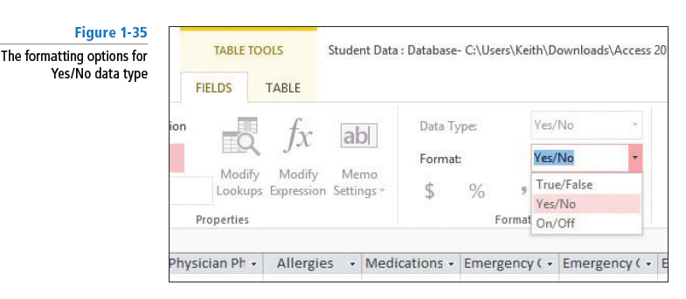
NOTE: Go to the MOAC page 31 and read the descriptions of the various Data Types available in Access

- PAUSE. LEAVE Microsoft Access open to use in the next exercise.

In database applications like Access, you can create a relational database. A relational database stores information in separate tables and these tables are connected or linked by a defined relationship that ties the data together.

STEP BY STEP L1-13 Define Database Tables

USE the database you used in the previous exercise.

- On the DATABASE TOOLS tab, in the Relationships group, click Relationships to display a visual representation of the relationship between the Students and Guardians tables, as shown in Figure 1-36 below.
- CLOSE the Relationships tab.
- CLOSE the Students tab.

STOP. CLOSE the database.

