plickers - codes used to scan class work
- https://www.youtube.com/watch?v=dMAX2EQnUXE
- https://www.youtube.com/watch?v=Qpx56rjCVjQ

seesaw - (blogs, journals)
- https://www.youtube.com/watch?v=tlw-tUKvnNc
- https://app.seesaw.me/#/class/class.23b466bf-84e9-4929-a11f-c8446959230e

classkick -
- https://www.youtube.com/watch?annotation_id=annotation_2576143983&feature=iv&src_vid=HvSxM9KpTDE&v=BwnwaLkQgmg

- nearpod (edted tool)
- https://www.youtube.com/watch?v=ThlqFu1qIlM
- monitor student assessment when completed and while completing
- share video with class
- students responses can be graded for instant feedback
- Reports tab is available for immediate feedback

Apps
- Bento: ...
- TED: ...
- Evernote: ...
In addition to dos, Evernote allows you to take notes, save links and images, and sort your work into multiple projects, and also syncs automatically between devices, so you can take notes from anywhere and work on projects back at your desk. This is great not only for you, but for your learners, who can use the app to manage their coursework along with their workloads. As a mobile learning app in particular, it’s ideal for time management courses.
Evernote is free,
- Instapaper: ...
- Wolfram Alpha:
- udemy
I love any eLearning tool that comes with a course library. Udemy skips to the good part by simply being a library. Referring to themselves as “a global marketplace for learning and teaching online,” Udemy is an open course library you can use to craft or add onto your eLearning courses. Assign courses to your students and let the pre-made lessons and assignments do the rest.

Attachments area
Preview YouTube video Plickers In The Classroom
Plickers In The Classroom
Preview YouTube video Plickers - A Step by Step Tutorial
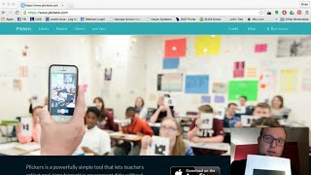
Preview YouTube video Seesaw: The Learning Journal Overview
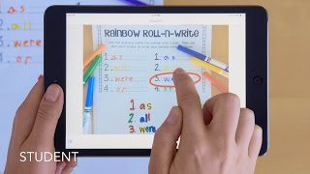
Seesaw: The Learning Journal Overview
Preview YouTube video Welcome to Classkick
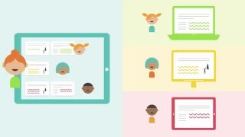
Welcome to Classkick
Preview YouTube video Nearpod - How it Works
