Competency Assessments

Project 2-1: Creating a Highly Desired Housing Options Workbook
Create a new workbook for Fabrikam, Inc., that is a result of a focus group showing the most
desired options for houses for first-time home buyers.
GET READY. LAUNCH Excel and start a new blank workbook.
1. Click cell A1 and type Fabrikam, Inc. and press Enter.
2. Click cell A2 and type Focus Group Requests (Age 20-30).
3. Beginning in A4, type the following labels and values. Press Tab between each new cell
and Enter to move to a new row:
Option Priority Cost
Gameroom Low 25,000
Exercise equipment Low 2500
Fenced yard for dog Medium $10,000
Flat screen HDTV Medium 1000
Furnished Medium 15000
Washer & dryer High 1500
Dishwasher Medium 1000
Near bike path High 0
Basketball hoop Low 100
4. If necessary, adjust the column widths to display all of the text in the columns.
5. Drag the fill handle from C5 through C13 and choose Fill Formatting Only.
6. SAVE the workbook as 02 Focus Group Solution in the Excel Lesson 2 folder you
created in a previous exercise.
PAUSE. LEAVE the workbook open for the next project.

Project 2-2: Setting Document Properties and Assigning Keywords
Use Document Properties to assign document properties to an existing workbook.
GET READY. If necessary, OPEN the 02 Focus Group Solution workbook you created in the previous project.
1. Click the FILE tab.
2. Click Properties, and then click Show Document Panel.
3. Click the Author field, type [your name], and press Tab.
4. In the Title field, type Focus Group Requests and press Tab.
5. In the Subject field, type Sales and press Tab.
6. In the Keywords field, type 20-30, options, priorities.
7. Click the Status field, and type Needs to be formatted.
8. SAVE the file as 02 Focus Properties Solution.
9. At the top of the Document Information Panel, click the Close (X) button.
10. CLOSE the file.
PAUSE. LEAVE Excel open for the next project.

Proficiency Assessments

Project 2-3: Creating a Commission Schedule
You have been asked to create a commission schedule in 5 minutes or less. Because you know how to use the fill handle, you should be able to quickly create the following workbook.
GET READY. OPEN a blank workbook.
1. Create the entries shown in the figure below. 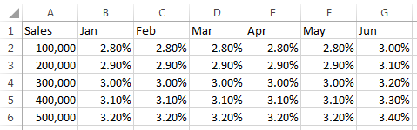
2. Move the table so you can add text in cell A1, cell A2, and a blank cell in A3.
3. Click cell A1 and type Fabrikam Incorporated.
4. Click cell A2 and type Commission Schedule.
5. Add the following Document Properties:
Property Value
Author [Your Name]
Title Commission Schedule
Keywords Agent, Amount, Sales
Category Revenue
6. SAVE the file as 02 Commission Solution and CLOSE the workbook.
PAUSE. LEAVE Excel open for the next project.

Project 2-4: Advertising Expenditures
Fourth Coffee specializes in unique coffee and tea blends. Create a workbook to track and classify expenditures for January.
GET READY. OPEN a blank workbook.
1. Click cell A1 and type Fourth Coffee.
2. Click cell A2 and type January Expenditures.
3. Enter the following column headings in row 4: Date, Check No, Paid to, Category, and Amount.
4. Enter the following expenditures data in the appropriate columns:
January 3, paid $3,000 to World Wide Importers for coffee, Check No. 4076
January 20, paid $600 to Northwind Traders for tea, Check No. 4077
January 22, paid $300 to City Power and Light for utilities
January 28, paid $200 to A. Datum Corporation for advertising
January 29, paid $2,500 to World Wide Importers for coffee
5. Checks are written sequentially. Use the fill handle to enter the missing check numbers.
6. Adjust column widths as needed.
7. SAVE the workbook as 02 Advertising Expenses Solution. CLOSE the workbook.
LEAVE Excel open for the next project.

Mastery Assessments

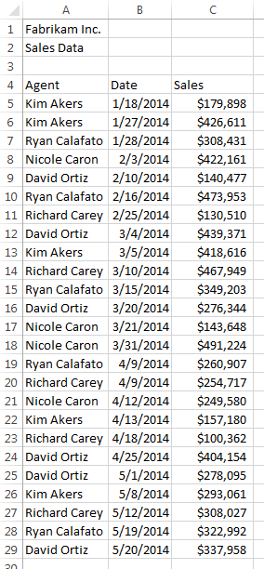
Project 2-5: Creating a Home Sales Workbook
Richard Carey asked you to keep track of the home sales for the Fabrikam staff. Each person sends you an e-mail with the home sales information.
GET READY. OPEN a blank workbook.
1. Create the workbook with the data in the figure to the right.
2. SAVE the workbook as 02 Home Sales Solution.
3. Create a New workbook and copy the data and titles for the first quarter only.
4. Click cell A3 and type First Quarter 2014.
5. Move the Agent, Date, and Sales titles and data down so there is a blank row in row 4.
6. SAVE the new workbook as 02 Home Sales Q1 Solution.
7. Repeat for the second quarter (4/9/2014-5/20/2014) and SAVE the workbook as 02 Home Sales Q2 Solution.
CLOSE the workbooks and LEAVE Excel open for the next project.

Project 2-6: Using Flash Fill
Fabrikam’s director has asked you to redo the workbook you created in Project 2-5 with separate columns for first name and last name and sequentially numbered sales. Save this as a PDF and Excel 1997-2003 file formats and with document properties in the new file.

1. OPEN the 02 Home Sales Solution file.
2. Use Flash Fill to create columns for the First and Last name.
3. Delete the content of cells A4:A29.
4. In A4, type Item# and then use Auto Fill to create numbers starting with 1 that are sequential through 25.
5. Add a label in A3 that says 2014 To-Date.
6. Make sure there is a blank row 4.
7. Add your own Document Properties for Author, Title, Subject, Keywords, Category, and Status. In the Comments, type Project 2-6 final review.
8. SAVE the workbook as 02 Home Sales Flash Fill Solution.
9. Create a PDF file and save it with the same name.
10. Verify whether there are any compatibility issues for earlier versions of Excel.
11. Create an Excel 1997-2003 file and SAVE it as 02 Home Sales Flash Fill 97-03 Solution.
CLOSE Excel.

