Lesson 4: Using Basic Formulas

Step-by-Step 1 – Display Formulas
GET READY. Before you begin these steps, LAUNCH Microsoft Excel and OPEN a new blank workbook.
1. Click cell A1.
2. Type =7+8*3/2-4 and press Enter. You just entered a formula.
Formulas should be typed without spaces, but if you type spaces, Excel eliminates them when you press Enter.
3. Click cell A1. Notice that the result of the formula displays in the cell, but the formula itself appears in the formula bar.
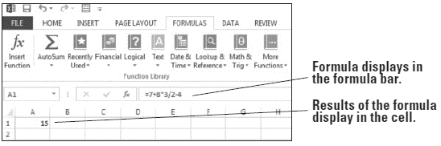
4. Double-click cell A1. The formula appears in both the active cell and the formula bar. You can edit the formula in this mode.
5. Press Enter.
6. On the FORMULAS tab, in the Formula Auditing group, click Show Formulas. The formula in cell A1 displays.
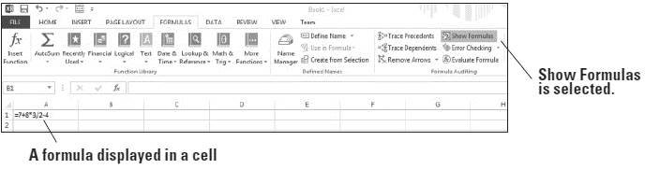
While you are displaying formulas, you will not see the results of those formulas.
7. Click Show Formulas again to turn off formula display.
8. SAVE the workbook in your Lesson 4 folder as 04 Formula Practice Solution.
PAUSE. LEAVE the workbook open to use in the next exercise.

Step-by-Step 2 – Understand the Order of Operations
GET READY. USE the worksheet from the previous exercise.
1. Click cell A1 to make it the active cell.
2. Click in the formula bar.
3. Insert parentheses around 7 + 8.
4. Insert parentheses around 3 / 2.
5. Insert parentheses around (7 + 8) * (3 / 2), as shown in the formula bar. Press Enter. The result in A1 changes to 18.5.
6. SAVE the workbook in your Lesson 4 folder as 04 Order of Operations Solution and CLOSE it.
PAUSE. LEAVE Excel open to use in the next exercise.

Step-by-Step 3 – Create a Formula that Performs Addition
GET READY. LAUNCH Microsoft Excel if it is not already open.
1. OPEN the 04 Budget Start data file for this lesson.
2. In cell A18, type January Rent plus Deposit and press Enter.
3. In cell B18, type the equal (=) sign, type 1200+500, and press Enter. This is the simplest way to enter an addition formula. Excel adds the values in the formula and displays the result, 1700, which is your first month’s rent plus a $500 deposit. Your worksheet now looks like that shown.
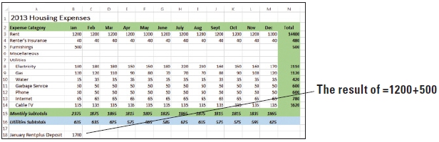
4. SAVE the workbook in your Lesson 4 folder as 04 Budget Basic Formulas Solution.
PAUSE. LEAVE the workbook open to use in the next exercise.

Step-by-Step 4 – Create a Formula that Performs Subtraction
GET READY. USE the worksheet you modified in the previous exercise.
1. Double-click cell A18.
2. Click after the word “Deposit,” type , minus Discount, and press Enter.
3. Right-click cell A18, select Format Cells, click the Alignment tab, select the Wrap text check box, and click OK. Now you can see all of the new text added to A18.
4. Click cell B18 to make it the active cell.
5. Click in the formula bar.
6. Position the cursor immediately after =1200+500, type -100, and press Enter. Your landlord gave you a $100 discount for moving into your rental home early, so you are subtracting $100 from your first month’s rent. The value in cell B18 changes to 1600 to reflect the new formula.
7. SAVE the workbook.
PAUSE. LEAVE the workbook open to use in the next exercise.
When you modified the formula to subtract 100 from 1700, you could have entered =1200+500−100 or = −100+1200+500. Either formula yields a positive 1600.

Step-by-Step 5 – Create a Formula that Performs Multiplication
GET READY. USE the worksheet you modified in the previous exercise.
1. In cell A19, type Annual Rent per Lease and press Enter.
2. In cell B19, type =1200*12 and press Enter. The result displays in cell B19, which is the total amount of rent you will pay in one year.
3. SAVE the workbook.
PAUSE. LEAVE the workbook open to use in the next exercise.

Step-by-Step 6 – Create a Formula that Performs Division
GET READY. USE the worksheet you modified in the previous exercise.
1. In cell A20, type Average Electricity and press Enter.
2. In cell B20, type =N8/12 and press Enter. The result displays in cell B20, which is the average monthly amount you will pay for electricity in one year.
3. SAVE the workbook and CLOSE it.
PAUSE. LEAVE Excel open to use in the next exercise.

Step-by-Step 7 – Use Relative Cell References in a Formula
GET READY. OPEN the 04 Budget Cell References data file for this lesson.
1. Click cell B18.
2. Click in the formula bar and replace 1200 with cell B3. Notice that cell B3 is highlighted and surrounded by a blue border while you’re modifying the formula.
You can use either uppercase or lowercase when you type a cell reference in a formula. For example, it does not matter whether you type B4 or b4 in the formula you enter.
3. Press Enter. The formula in cell B18 now uses a relative cell reference to cell B3.
4. Copy cell B18 to cell B21. The displayed result changes to 400.
5. Notice in the formula bar that the formula in cell B21 is =B6+500-100, but the formula you copied is =B3+500-100. That’s because the original cell reference of cell B3 changed to cell B6 when you copied the formula down three cells, and cell B6 is blank. The cell reference is adjusted relative to its position in the worksheet.
6. An alternate way to use a cell reference is to click the cell being referenced while creating or modifying a formula. With cell B21 still active, click in the formula bar and select B6.
7. Click cell B3. Cell B3 becomes highlighted and surrounded by a blue dashed border, and cell B3 appears in the formula bar rather than cell B6 (see Figure 4-10). Press Enter.
8. SAVE the workbook in your Lesson 4 folder as 04 Budget Cell References Solution.
PAUSE. LEAVE the workbook open to use in the next exercise.

Step-by-Step 8 – Use an Absolute Cell Reference in a Formula
GET READY. USE the worksheet you modified in the previous exercise.
1. Click cell B18.
2. Click in the formula bar and insert dollar signs in the B3 cell reference so it looks like $B$3.
3. Press Enter. The formula in cell B18 now uses an absolute cell reference to cell B3.
4. Copy cell B18 to cell B21. The displayed result is 1600, which matches B18.
5. Copy cell B21 to cell C21. The displayed result is still 1600.
6. Notice in the formula bar that the formulas in cells B21 and C21 are both =$B$3+500-100. Figure 4-11 shows the formula for cell C21. Regardless of where you copy the formula in the worksheet, the formula still refers to cell B3.
7. SAVE the workbook.
PAUSE. LEAVE the workbook open to use in the next exercise.

Step-by-Step 9 – Use a Mixed Cell Reference in a Formula
GET READY. USE the worksheet you modified in the previous exercise.
1. Click cell B21.
2. Click in the formula bar and delete the dollar sign before 3 in the formula so it looks like $B3.
3. Press Enter. The formula in cell B21 now uses a mixed cell reference.
4. Copy cell B21 to cell C22. The displayed result is 440, which is different from the result in B21. That’s because the formula in C22 references cell B4 (see Figure 4-12). The dollar sign before the B in the formula is absolute, but the row number is relative.
5. Delete the contents of cell B21, cell C21, and cell C22.
6. SAVE the workbook.
PAUSE. LEAVE the workbook open to use in the next exercise.

Step-by-Step 10 – Refer to Data in Another Worksheet
GET READY. USE the worksheet you modified in the previous exercise.
1. Click the Summary sheet tab in the 04 Budget Cell References Solution workbook.
2. Click cell D8. You want the average payment for electricity to appear in this cell, similar to the content that appears in B20 in the Expense Details worksheet. However, your formula must reference the Expense Details worksheet to gather the data.
3. Type =SUM(‘Expense Details’!N8)/12 and press Enter. This formula divides the value of cell N8 in the Expense Details worksheet by 12. The result is 176, rounded due to cell formatting applied to the worksheet (see the figure).
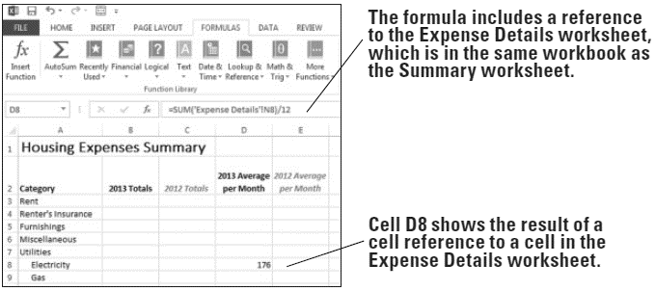
4. SAVE the workbook.
PAUSE. LEAVE the workbook open to use in the next exercise.

Step-by-Step 11 – Reference Data in Another Workbook
GET READY. USE the worksheet you modified in the previous exercise.
1. Open a second workbook, the data file named 04Budget2012.
2. In 04 Budget Cell References Solution, on the Summary sheet, click cell C3.
3. Type =([04Budget2012.xlsx]Summary!B3), as shown in Figure 4-14, and press Enter. The formula links to cell B3 on the Summary sheet in the workbook named 04Budget2012.
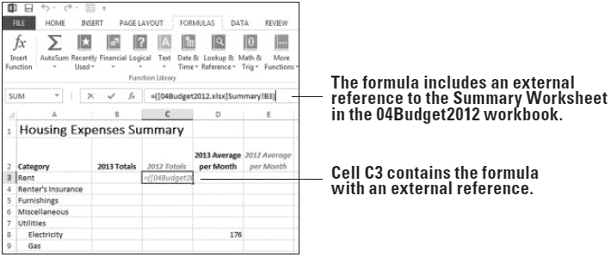
4. SAVE the workbook and CLOSE it.
5. CLOSE 04Budget2012.
PAUSE. LEAVE Excel open to use in the next exercise.

Step-by-Step 12 – Name a Range of Cells
Get Ready. OPEN the 04 Budget Ranges data file for this lesson.
1. Click Enable Content, if prompted. Click the Expense Details sheet tab.
2. Select B3:B14. These are the cells to be named.
3. To the left of the formula bar, click the Name box.
4. Type a one-word name for the list, such as Q1Expenses, and press Enter. The range name appears in the Name box (see Figure 4-17). Excel saves this name and uses it in any subsequent reference to this range. (Don’t worry about the apparent misnaming of the range. You modify this range to include additional months in an exercise later in this lesson.)
When naming a range, if a message appears stating that the name already exists, display the Name Manager (discussed in the “Changing the Size of a Range” section) and edit the existing name or delete it and enter a different name.
5. An alternative way to name a range is to use the New Name dialog box. Select B16:M16.
6. On the FORMULAS tab, in the Defined Names group, click Define Name. The New Name dialog box appears.
7. Excel uses the row heading as the range name, shown in the Name text box. You can change the name if you like. For this exercise, leave the default name.
8. Open the Scope drop-down list. Your options are Workbook, Expense Details, and Summary. The last two entries correspond to individual sheets in the workbook. Close the drop-down list, leaving Workbook selected.
9. Enter comments in the Comments text box, if you like.
10. Leave the cell address that appears in the Refers to text box. This is the range you selected. Notice that the sheet name is also included automatically.
11. Click OK. The name Utilities_Subtotals is saved for the range B16:M16.
12. A third way to name a range is to use the Create Names from Selection dialog box. Select N2:N14. This selection includes the column heading label.
13. On the FORMULAS tab, in the Defined Names group, click Create from Selection. The Create Names from Selection dialog box appears.
14. Excel determines that you want to use the column heading label as the range name. Click OK. The range is saved with the name Total.
15. Open the Name box drop-down list. You have three named ranges from which to select.
16. SAVE the workbook in your Lesson 4 folder as 04 Budget Ranges Solution.
PAUSE. LEAVE the workbook open to use in the next exercise.

Step-by-Step 13 – Change the Size of a Range
Get Ready. USE the worksheet you modified in the previous exercise.
1. Click the Expense Details sheet, if it’s not already active.
2. On the FORMULAS tab, in the Defined Names group, click Name Manager.
3. Select Q1Expenses.
4. At the bottom of the dialog box, highlight everything in the Refers to box.
5. In the Expenses Details worksheet, select B3:D14. The content in the Refers to box in the Name Manager dialog box reflects the new range.
6. Click Close, and then click Yes when asked if you want to save your changes.
7. SAVE the workbook.
PAUSE. LEAVE the workbook open to use in the next exercise.

Step-by-Step 14 – Create a Formula that Operates on a Named Range
Get ready. Use the worksheet you modified in the previous exercise.
1. In the Expense Details sheet, click A21.
2. Type First Quarter Expenses and press Enter.
3. In cell B21, type =SUM(.
4. On the FORMULAS tab, in the Defined Names group, click Use in Formula.
5. Select Q1Expenses from the list (see Figure 4-23), type ) to close the equation, and press Enter. The total amount of expenses for January through March appears in cell B21.
6. SAVE the workbook.
PAUSE. LEAVE the workbook open to use in the next exercise.

Step-by-Step 15 – Keep Track of Named Ranges
GET READY. USE the worksheet you modified in the previous exercise.
1. Open the Name box drop-down list. The names of all named ranges available in that workbook display.
2. To verify your change to the size of the Q1Expenses range in a previous exercise, select Q1Expenses. The range B3:D14 appears highlighted.
3. On the FORMULAS tab, in the Defined Names group, click Name Manager. Each named range is listed in the dialog box. You can use Name Manager to create a new range, rename a range, delete a range, and verify the scope of a range, among other tasks.
4. Click Close to close the Name Manager.
5. To display range names and their cell ranges as data in the worksheet, select a cell with blank cells to the right and below it, such as cell P2.
6. On the FORMULAS tab, in the Defined Names group, click Use in Formula and then select Paste Names. The Paste Name dialog box opens.
7. Click Paste List. Widen the width of column P to display all range names fully. Range names display in column P and their cell ranges display in column Q.
8. SAVE the workbook and CLOSE it.
CLOSE Excel.

