Lesson 7: Formatting Worksheets

Step-by-Step 1 – Insert and Delete Rows and Columns
GET READY. Before you begin these steps, be sure to launch Microsoft Excel.
1. Open the workbook named 07 Messenger Row-Column.
2. Click the row 14 heading to select the entire row.
3. On the HOME tab, in the Cells group, click the Insert button arrow and select Insert Sheet Rows, as shown in Figure 7-2. A new blank row appears as row 14.
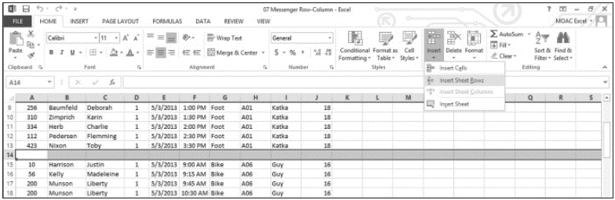
4. To insert several rows at once, click the row 25 heading, hold down the Ctrl key, and then click row headings 34 and 43. Right-click any of the selected rows and select Insert from the shortcut menu. Blank rows appear above the selected rows, so that data for each messenger is separated by a blank row.
5. Click the column D heading to select the entire column. This column contains the delivery zone.
6. On the HOME tab, in the Cells group, click the Delete button arrow and select Delete Sheet Columns. The Zone column disappears.
7. Right-click the row 3 heading and select Insert from the shortcut menu. In cell A3, type
Zone 1.
8. Select A3:I3. On the HOME tab, in the Alignment group, click the Merge & Center button. The “Zone 1” text is centered across the data columns.
9. SAVE the workbook as 07 Messenger Row-Column Solution.
Pause. Leave the workbook open to use in the next exercise.

Step-by-Step 2 – Modify Row Height and Column Width
GET READY. USE the workbook from the previous exercise.
1. Double-click the boundary to the right of the column G heading (see Figure 7-3), which adjusts the column width to show all content in column G.
2. Click anywhere in column H. On the HOME tab, in the Cells group, click the Format button arrow and select Column Width. In the Column Width dialog box (see Figure 7-4), in the Column width text box, type 16 and then click OK. All content in column H appears.
3. Click and hold the boundary under the row 3 heading. Drag the line up to decrease the height of row 3 to 18, as shown in Figure 7-5. Notice that a ScreenTip appears as you drag the boundary line, showing you the height of the row in points (the first number) and pixels.
4. Select row 2. On the HOME tab, in the Cells group, click the Format button arrow and select AutoFit Row Height. With the row still selected, click the Format button arrow again and select Row Height. The Row Height dialog box indicates that the row is 18.75 points in height. Click OK.
5. SAVE the workbook.
Pause. Leave the workbook open to use in the next exercise.

Step-by-Step 3 – Format an Entire Row or Column
GET READY. Use the workbook from the previous exercise.
1. Select columns F through I by clicking the column f heading, pressing the Shift key, and clicking the column i heading. All four columns are selected, as shown in Figure 7-6.
2. On the HOME tab, in the Alignment group, click the Center icon, as shown in Figure 7-7. The content in columns F through I is centered.
3. Click the column i heading. The Charge column is selected.
4. On the HOME tab, in the Number group, select Currency from the Number Format menu. Only the values in column I are styled as currency.
5. Select row 4 and center the column headings using the Center icon.
6. SAVE the workbook.
Pause. Leave the workbook open to use in the next exercise.

Step-by-Step 4 – Hide or Unhide a Row or Column
GET READY. USE the workbook from the previous exercise.
1. Select columns D and E. The columns for Date and Time are selected.
2. Right-click the column D or E heading and select Hide. The Date and Time columns are hidden from view, and a green line appears, indicating hidden content, as shown in Figure 7-8.
3. Click in any cell. The green line disappears, and the boundary between columns C and
F is a double vertical line (see Figure 7-9), which indicates hidden columns.
4. Select row 3. On the HOME tab, in the Cells group, click the Format button arrow, point to Hide & Unhide, and select Hide Rows, as shown in Figure 7-10. Row 3 is now hidden.
5. Select rows 2 and 4. Right-click the selection and select Unhide. Row 3 is now visible.
When you select rows 2 and 4 to unhide the hidden row, you must select them in a way that includes the hidden rows. Press Shift when you select row 4 or select row 2 and drag to include row 4. If you select row 2, press Ctrl, and click row 4, the hidden row will not unhide. Additionally, selecting only the data in the rows will not release the hidden row.
6. SAVE the workbook.
Pause. Leave the workbook open to use in the next exercise.

Step-by-Step 5 – Transpose Rows or Columns
GET READY. USE the workbook from the previous exercise.
1. Click the Sheet2 tab.
2. Select rows 2 through 7, and then press Ctrl + C to copy the data to the Clipboard. A green marquee border appears.
3. Click cell A10.
4. On the HOME tab, in the Clipboard group, click the Paste button arrow and select Paste Special. The Paste Special dialog box opens.
5. Check the Transpose check box, as shown in the figure below.
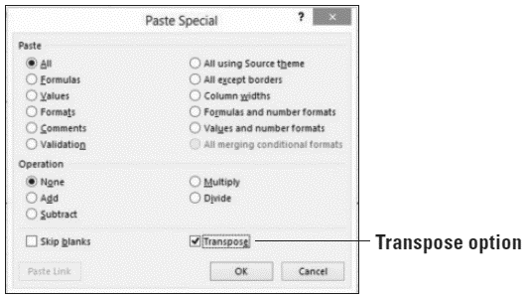
6. Click OK. The data appears with the row data in columns and the column data in rows, as shown in Figure 7-12. 7. Click the Sheet1 tab to return to the main worksheet.
8. SAVE the workbook and CLOSE the file.
Pause. Leave Excel open to use in the next exercise.

Step-by-Step 6 – Choose a Theme for a Workbook
GET READY. Launch Excel if it is not already running.
1. OPEN the 07 Messenger Theme data file for this lesson.
2. With Sheet1 active, click cell A3.
3. On the HOME tab, in the Styles group, click the Cell Styles button arrow and select
20% - Accent 4. A light purple background is applied to the cell range, the font size is reduced, and the font color changes to black.
4. On the PAGE LAYOUT tab, in the Themes group, click the Themes button arrow to open the Themes gallery. Several built-in themes appear in the gallery. Move your mouse pointer over each theme to see its effect on the underlying worksheet, which is referred to as Live Preview.
5. Find and select the Facet theme. You just changed the default document theme to the Facet theme. The font for subheadings and general data changed from Calibri to Trebuchet MS, and the background of cells A3:I3 is now a light pink color.
6. Click Sheet2. Notice that the font changed on that sheet as well.
7. Click Sheet1 to return to the main worksheet. On the HOME tab, in the Styles group, click the Cell Styles button arrow to display the Styles gallery. Notice that the color schemes for the various groups have changed. This is because a new document theme has been applied, and several built-in cell styles were created using theme fonts and colors.
8. SAVE the workbook as 07 Messenger Theme Solution.
Pause. Leave the workbook open to use in the next exercise.

Step-by-Step 7 – Customize a Theme by Selecting Colors
GET READY. USE the workbook from the previous exercise.
1. Ensure Sheet1 is active.
2. On the PAGE LAYOUT tab, in the Themes group, click Colors. Figure 7-14 illustrates the color array for some of the built-in themes. You have to scroll through the entire list to see them all. Each theme has an array of accent colors that are the same as the accents in the Styles group.
3. Scroll down and select Violet II .
4. Open the Colors menu again and click Customize Colors at the bottom of the menu. The Create New Theme Colors dialog box opens (see Figure 7-15), showing the colors used with the Violet II color scheme currently applied to the Facet theme. Move the dialog box so you can see the worksheet more clearly, if necessary.
5. Open the Text/Background - Dark 2 drop-down list. The current color is highlighted under Theme Colors. Click Black, Background 1, Lighter 15% to change the color to dark gray.
6. In the Name box at the bottom of the dialog box, type Consolidated Messenger and click Save. The new text color is reflected in row 1. If you want to modify colors for Consolidated Messenger in the future, just modify the Consolidated Messenger color scheme, which appears at the top of the Colors menu.
7. SAVE the workbook.
Pause. Leave the workbook open to use in the next exercise.

Step-by-Step 8 – Customize a Theme by Selecting Fonts and Effects
GET READY. USE the workbook from the previous exercise.
1. With Sheet1 active, on the PAGE LAYOUT tab, in the Themes group, click Fonts.
2. Click Customize Fonts. The Create New Theme Fonts dialog box opens.
3. Open the Heading font drop-down menu, locate the Arial font, and select it.
4. In the Body font box, locate and select Arial Narrow. The preview in the Sample box is updated with the fonts that you selected.
5. In the Name box, type Consolidated Messenger as the name for the new theme fonts and click Save. Your customized theme fonts will be available for you to use to customize any of the built-in themes or to use the next time you click Cell Styles on the HOME tab.
If your customized theme font is not automatically applied, click Cell Styles and click the customized heading font to apply it. For example, click A1, go to Cell Styles on the HOME tab, and select Title.
6. On the PAGE LAYOUT tab, in the Themes group, click Themes and then click Save Current Theme. The Save Current Theme dialog box opens.
7. In the File name box, type Consolidated Messenger and click Save. Your customized document theme is saved in the Document Themes folder, and it is automatically added to the list of custom themes that now appears at the top of the Themes gallery.
8. On the PAGE LAYOUT tab, in the Themes group, click Effects. Theme effects are sets of lines and fill effects. Hovering your mouse over the effects might show subtle changes in the cells; however, you will notice the result of changing an effect only if you have charts, shapes, SmartArt, or similar graphics in your workbook.
9. Click the Reflection effect to apply it to the workbook. In the Quick Access Toolbar, click Undo to undo the theme effect.
10. SAVE the workbook and CLOSE the file.
Pause. Leave Excel open to use in the next exercise.

Step-by-Step 9 – Format a Worksheet Background
GET READY. Launch Excel if it is not already running.
1. OPEN the 07 Messenger Appearance data file for this lesson.
2. Ensure Sheet1 is active.
3. On the PAGE LAYOUT tab, in the Page Setup group, click the Background button. The Insert Pictures dialog box opens.
4. Click Browse next to From a file. The Sheet Background dialog box opens.
5. Navigate to the student data files folder, select 07 bike_courier.jpg, and then click Insert. The selected picture is displayed behind the text and fills the worksheet, as shown in Figure 7-19.
6. On the PAGE LAYOUT tab, in the Page Setup group, click Delete Background. The background is removed.
7. SAVE the workbook as 07 Messenger Appearance Solution.
Pause. Leave the workbook open to use in the next exercise.

Step-by-Step 10 – View and Print a Worksheet’s Gridlines
GET READY. USE the workbook from the previous exercise.
1. Ensure Sheet1 is active.
2. On the PAGE LAYOUT tab, in the Sheet Options group, uncheck the Gridlines View check box. The gridlines disappear from the worksheet.
3. Check the Gridlines View check box to restore viewable gridlines.
4. Check the Gridlines Print check box, as shown in Figure 7-20. This action will force gridlines to appear in your printed worksheet.
5. Click the Dialog Box Launcher in the Sheet Options group to open the Page Setup dialog box.
6. On the Sheet tab, notice that the Gridlines check box is checked. Click the Print Preview button. Gridlines appear in the preview, as shown in Figure 7-21.
7. In the upper-left corner of the Print window, click the Back button to return to the worksheet.
8. SAVE the workbook.
Pause. Leave the workbook open to use in the next exercise.

Step-by-Step 11 – View and Print Column and Row Headings
GET READY. USE the workbook from the previous exercise.
1. Ensure Sheet1 is active.
2. On the PAGE LAYOUT tab, in the Sheet Options group, uncheck the Headings View check box. The row and column headings disappear from the worksheet.
3. Check the Headings View check box to restore the row and column headings.
4. Check the Headings Print check box. This action forces row and column headings to appear in your printed worksheet.
5. In the Sheet Options group, click the Dialog Box Launcher to open the Page Setup dialog box.
6. On the Sheet tab, notice that the Row and column headings check box is checked. Click the Print Preview button. Row and column headings appear in the preview.
7. In the upper-left corner of the Print window, click the Back button to return to the worksheet.
8. On the PAGE LAYOUT tab, in the Sheet Options group, uncheck the Headings Print check box.
9. SAVE the workbook.
Pause. Leave Excel open to use in the next exercise.

Step-by-Step 12 – Add Page Numbers to a Worksheet
GET READY. Launch Excel if it is not already running.
1. OPEN the 07 Messenger Header-Footer data file for this lesson.
2. Ensure Sheet1 is active.
3. On the INSERT tab, in the Text group, click the Header & Footer button. The worksheet is now displayed in Page Layout view. Note that the center Header text box is active and the DESIGN tab is added to the ribbon, as shown in Figure 7-23. The Header & Footer DESIGN tab command groups are thus available for you to use in the worksheet. By default, your cursor will appear in the center Header section.
4. Click the Go to Footer button in the Navigation group on the ribbon. The cursor appears in the center text box in the footer.
5. In the Header & Footer Elements group, click Page Number. The code &[Page] appears in the text box, as shown in Figure 7-24. The ampersand symbol (&) indicates that the appropriate page number will be added to each page of the printed worksheet.
6. Click in a worksheet cell that’s not part of the footer, and then click the Normal view icon on the right side of the status bar.
7. SAVE the workbook as 07 Messenger Header-Footer Solution.
Pause. Leave the workbook open to use in the next exercise.

Step-by-Step 13 – Insert a Predefined Header or Footer
GET READY. USE the workbook from the previous exercise.
1. Ensure Sheet1 is active. Click cell A1.
2. On the VIEW tab, in the Workbook Views group, click the Page Layout view button to view headers and footers.
3. Click the center header text box (which displays the “Click to add header” placeholder text). Click the Header & Footer Tools DESIGN tab now that it has become active. In the Header & Footer Elements group, click Sheet Name. &[Tab] appears in the text box.
4. In the Navigation group, click Go to Footer. Click the right footer text box.
5. In the Header & Footer group, click the Footer button arrow, and click the last option in the list, which combines Prepared by username, Current Date, and Page Number.
Because the footer is wider than the right text box, the majority of the footer is moved to the center text box, and the page number appears in the right text box.
6. SAVE the workbook.
Pause. Leave the workbook open to use in the next exercise.

Step-by-Step 14 – Add Content to a Header or Footer
GET READY. Use the workbook from the previous exercise.
1. With Sheet1 active and in Page layout view, click the center header text box and delete the existing header. You can click the DeSiGn tab and then click Go to Header to move to the header quickly.
2. Type Consolidated Messenger Zone 1 attorney Deliveries. When you preview your worksheet for printing or print the worksheet, you will see the header text.
3. SAVE the workbook.
Pause. Leave the workbook open to use in the next exercise.

Step-by-Step 15 – Insert a Watermark
GET READY. USE the workbook from the previous exercise.
1. Ensure Sheet1 is active and in Page Layout view.
2. Click the left header text box.
3. On the DESIGN tab in the Header & Footer Elements group, click Picture. Click the Browse button, navigate to the student data files folder, select 07 watermark.gif, and then click Insert. Excel inserts an &[Picture] code into the left header text box.
4. Click outside of the header area, and then click the Normal view icon on the status bar.
5. Click the FILE tab and then click Print. The preview shows the watermark in your worksheet. Click the Back button to exit Print Preview.
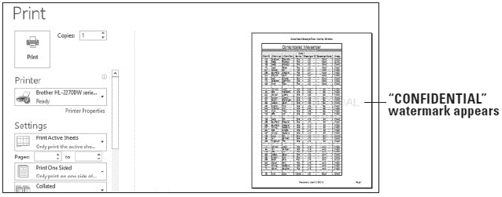
6. SAVE the workbook.
Pause. Leave the workbook open to use in the next exercise.

Step-by-Step 16 – Repeat Headers and Footers
GET READY. USE the workbook from the previous exercise.
1. Ensure Sheet1 is active and in Normal view.
2. On the PAGE LAYOUT tab, in the Page Setup group, click the Print Titles button. The Page Setup dialog box opens to the Sheet tab.
3. Type A1:I54 in the Print area text box. This is the range of all data on Sheet1 to be printed.
You learned how to set the print area and some other print features in Lesson 3.
4. In the Rows to repeat at top text box, type 1:4, as shown in Figure 7-28. This will repeat the first four rows of the worksheet, which includes column headings, on every page.
5. Click Print Preview. The Print Preview window appears. Click the right-facing arrow at the bottom of the screen to advance to the second page. The first four rows of the worksheet appear on the second page (see Figure 7-29). Click the left-facing arrow to return to the preview of page 1.
6. Click the Back button to return to the worksheet.
7. SAVE the workbook and CLOSE the file.
Pause. Leave Excel open to use in the next exercise.

Step-by-Step 17 – Add and Move a Page Break
GET READY. La unch Excel if it is not already running.
1. OPEN the 07 Messenger Print data file for this lesson.
2. Ensure Sheet1 is active.
3. On the VIEW tab, in the Workbook Views group, click Page Break Preview. Scroll down to view the entire print area. Notice that a dashed blue line appears after row 47 (see Figure 7-30). The dashed line is an automatic page break inserted by Excel.
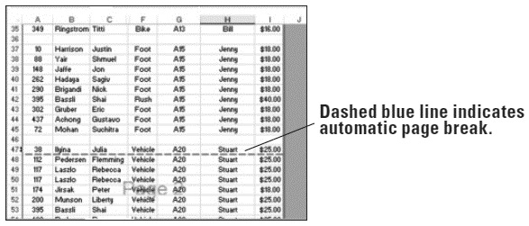
4. Click and hold the horizontal automatic page break and drag it upward so it is now below row 46. The automatic page break is now a manual page break represented by a solid blue line.
5. On the VIEW tab, in the Workbook Views group, click Normal.
6. SAVE the workbook as 07 Messenger Print Solution.
Pause. Leave the workbook open to use in the next exercise.

Step-by-Step 18 – Set Margins
GET READY. Use the workbook from the previous exercise.
1. Ensure Sheet1 is active and in Normal view.
2. On the PAGE lAYOuT tab, in the Page Setup group, click the Margins button arrow to open the Margins menu.
3. At the bottom of the menu, click Custom Margins. The Page Setup dialog box opens to the Margins tab, as shown in the figure below.
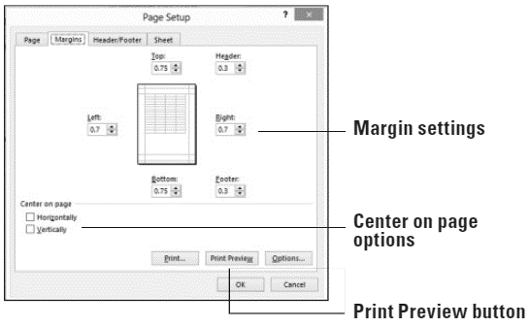
4. Change the left and right margins to 1.4. This will make the margins slightly wider than normal.
5. Check the Center on page Horizontally check box. The content in your worksheet will print centered.
6. Click Print Preview. The page is centered horizontally.
7. Click the Back button to leave Backstage.
8. SAVE the workbook.
Pause. Leave the workbook open to use in the next exercise.

Step-by-Step 19 – Set a Worksheet’s Orientation
GET READY. USE the workbook from the previous exercise.
1. Ensure Sheet1 is active and in Normal view.
2. On the PAGE LAYOUT tab, in the Page Setup group, click Orientation and then click Landscape.
3. Click the FILE tab, and then click Print. Click through the pages to see the worksheet in Landscape orientation. If you decided to keep this orientation, you would need to adjust page breaks to display all content properly.
4. Click the Back button to leave Backstage.
5. Repeat Step 2 to change the orientation back to Portrait.
Pause. Leave the workbook open to use in the next exercise.

Step-by-Step 20 – Scale a Worksheet to Fit on a Printed Page
GET READY. USE the workbook from the previous exercise.
1. Ensure Sheet1 is active and in Normal view.
2. On the PAGE LAYOUT tab, in the Page Setup group, click Orientation and verify that Portrait is selected.
3. In the Scale to Fit group, click the Height arrow and select 1 page. The scale of the worksheet is reduced so that all rows fit on the same page.
4. Click the FILE tab, and then click Print. Notice that all rows appear on the page and that the content is smaller than it was previously, as shown in Figure 7-33. When output is reduced, it shrinks the height and width proportionally.
5. SAVE the workbook and CLOSE the file.
CLOSE Excel.

Competency Assessments

Project 7-1: Practice Working with Rows and Columns
Use the worksheet for the School of Fine Arts to practice working with rows and columns.
GET READY. Launch Excel if it is not already running.
1. OPEN 07 Fine Art from the data files for this lesson.
2. Click the column D heading to select the entire column.
3. On the HOME tab, in the Cells group, click the Format button arrow, point to Hide &
Unhide, and select Hide Columns. Column D is now hidden.
4. Click the column B heading to select the entire column.
5. On the HOME tab, in the Cells group, click the Format button arrow and select Column
Width. In the Column Width dialog box, type 11 in the Column width text box and click
OK.
6. Double-click the double boundary between column headings C and E. Column D appears.
7. Click the row 11 heading, right-click, and select Insert.
8. Enter the following in the blank row:
First Last Discipline Enrollment Date GPA
Bruce Keever Sculpture 10/15/2012 =SUM(3.4+3.5+3.7)/3
9. Click the plus (+) sign to the right of Sheet1 to create a new, blank worksheet.
10. Click Sheet1, select A2:E15, and press Ctrl + C to copy the content to the Clipboard.
11. Click Sheet2, and then click cell A1.
12. On the HOME tab, in the Clipboard group, click the Paste button arrow and select Paste
Special. The Paste Special dialog box opens.
13. Check the Transpose check box, and click OK.
14. In Sheet2, select all content.
15. On the HOME tab, in the Cells group, click the Format button arrow, and select AutoFit
Column Width.
16. Click Sheet1.
17. SAVE the workbook as 07 Fine Art Solution and CLOSE the file.
LEAVE Excel open for the next project.

Project 7-2: Change and Customize a Theme
You work for Wingtip Toys and have been asked to modify a sales worksheet to make it match the company color and font scheme.
GET READY. Launch Excel if it is not already running.
1. OPEN 07 Wingtip Toys from the data files for this lesson.
2. On the PAGE LAYOUT tab, in the Themes group, click the Themes button arrow to open the Themes menu.
3. Find and select the Slice theme.
4. In the Themes group, click Colors.
5. Scroll down and select the Slipstream color scheme.
6. On the PAGE LAYOUT tab, in the Themes group, click Fonts.
7. Locate the Gill Sans MT font and select it.
8. Click Fonts in the Themes group and select Customize Fonts.
9. Open the Heading font drop-down menu and select Arial. Click Save.
10. On the PAGE LAYOUT tab, in the Themes group, click Themes and then click Save Current Theme. The Save Current Theme dialog box opens.
11. In the File name box, type WingTipToys and click Save.
12. SAVE the workbook as 07 Wingtip Toys Solution and CLOSE the file.
LEAVE Excel open for the next project.

Proficiency Assessments

Project 7-3: Modify the Appearance of a Worksheet
Albert, the CEO’s administrative assistant at A. Datum, asked you to help him prepare documents to email to board members. Albert wants to enhance the appearance of the A. Datum sales worksheet, which will be viewed onscreen and may be printed.
GET READY. Launch Excel if it is not already running.
1. OPEN 07 ADatum Appearance from the data files for this lesson.
2. On the PAGE LAYOUT tab, in the Page Setup group, click the Background button. The Insert Pictures dialog box opens.
3. Next to From a file, click Browse. The Sheet Background dialog box opens.
4. Navigate to the student data files folder, select 07 confidential.png, and then click Insert.
5. On the PAGE LAYOUT tab, in the Sheet Options group, uncheck the Gridlines View check box. The gridlines disappear from the worksheet.
6. Check the Gridlines View check box to restore viewable gridlines.
7. On the PAGE LAYOUT tab, in the Page Setup group, click the Dialog Box Launcher. The Page Setup dialog box opens.
8. Click the Margins tab.
9. Check the Center on page Horizontally check box and the Vertically check box.
10. Click Print Preview. Verify that the content is centered horizontally and vertically, and then click the Back button to exit Print Preview.
11. SAVE the workbook as 07 ADatum Appearance Solution and CLOSE the file.
LEAVE Excel open for the next project.

Project 7-4: Insert Headers and Footers
Albert has returned for additional help with the A. Datum sales worksheet. He wants to make a few formatting changes and add a header and footer to the worksheet.
GET READY. La unch Excel if it is not already running.
1. OPEN 07 ADatum Header-Footer from the data files for this lesson.
2. Select A1:E1, and then on the HOME tab, in the Alignment group, click Merge & Center.
3. Select columns B through E. Center all content. You might have to click Center twice because some of the selected data is already centered. The first click removes centering for those cells, and the second click applies it to all selected cells.
4. On the PAGE LAYOUT tab, in the Page Setup group, click the Dialog Box Launcher. In the Page Setup dialog box, click the Margins tab.
5. Uncheck the Center on page Vertically check box. Click OK.
6. Click in row 10. On the PAGE LAYOUT tab, in the Page Setup group, click Breaks and select Insert Page Break.
7. On the INSERT tab, in the Text group, click Header & Footer. Type the text A. Datum March 2013 Board Meeting in the center header text box.
8. Click the Go to Footer button in the Navigation group. With the cursor in the center footer text box, click Footer in the Header & Footer group and select Confidential, <date>, Page 1.
9. Click outside of the header area, on the status bar, click the Normal view icon.
10. Preview the worksheet for printing.
11. SAVE the workbook as 07 ADatum Header-Footer Solution and CLOSE the file.
LEAVE Excel open for the next project.

Mastery Assessments

Project 7-5: Enhance a Worksheet and Prepare for Printing
Margie’s Travel is an agency that sells travel-related products and services to clients on behalf of third parties such as airlines, hotels, and cruise lines. You are preparing a worksheet that lists a variety of cruises for Fabrikam, an important client.
GET READY. Launch Excel if it is not already running.
1. OPEN 07 Cruises from the data files for this lesson.
2. Remove the background image from the worksheet.
3. Change the orientation of the worksheet to Landscape.
4. Change the margin setting to Narrow.
5. Change the document theme to Banded.
6. Center the worksheet horizontally for printing.
7. Preview the worksheet for printing.
8. SAVE the workbook as 07 Cruises Solution and CLOSE the file.
LEAVE Excel open for the next project.

Project 7-6: Formatting a Payroll Worksheet
Contoso, Ltd. is a busy family practice clinic that recently expanded its operations to a second location. You are formatting a payroll worksheet.
GET READY. Launch Excel if it is not already running.
1. OPEN 07 Payroll from the data files for this lesson.
2. AutoFit all columns so that all data is viewable.
3. Change the row height of rows 3 through 33 to 18.
4. Change the theme to Wisp.
5. Set rows 1 through 3 to repeat on every page, anticipating that additional rows will be added to a future revision of the worksheet.
6. Insert a footer that includes the file name and page number.
7. Configure gridlines to appear in printed worksheets.
8. Scale the width of the worksheet to fit on one page.
9. Preview the worksheet for printing.
10. SAVE the workbook as 07 Payroll Solution and CLOSE the file.
CLOSE Excel.

