Introduction to Game Development

Contents
What is Software?
What is Software Development?
What is Agile?
Designing Your World
Interface for Building Your World
Biomes
Paint
Sculpt
Props and Editing
Quick Help Guides for Designers
Programming Your World
Brain Editor
Koding
Quick Help Guides for Programmers
Testing Your World
Basic Help Guides
Xbox One Controller
References

What is Software?
Software is all around us! It’s in phones, cars, ovens, laptops, and even TVs we use every day. It “thinks” for us so we don’t have to do the hard stuff. Without software, our lives would be much different. Just think about math class without a calculator! Software, also known as computer programs, is a set of instructions we create to tell machines what to do. These instructions are called code. This can be as simple as adding 1 + 1, or as complex as building an entire 3D world.

Examples of Software
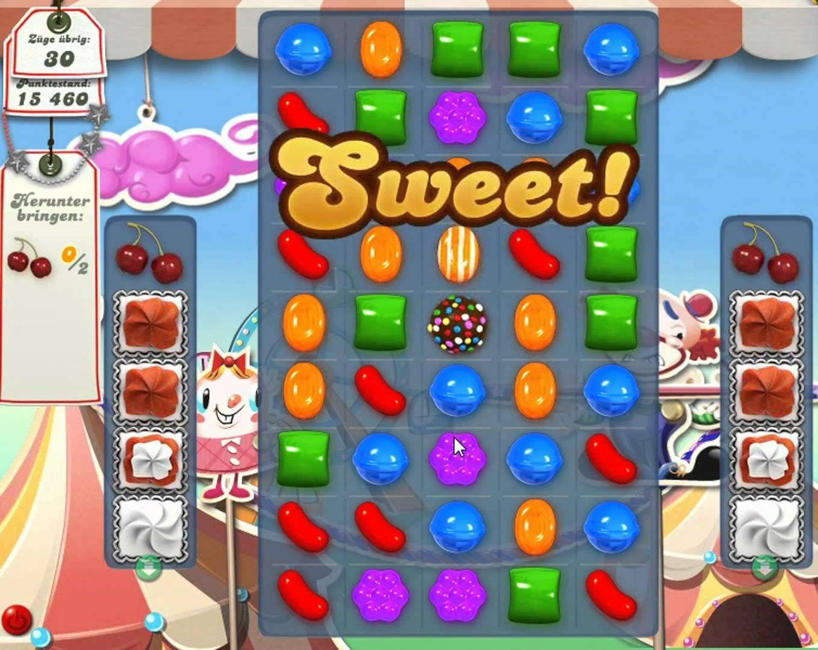
Candy Crush | Google Search Engine

In order to write software, you have to use what is called a computer programming language. There are many programming languages that can be used to tell machines what to do, such Java, C#, Ruby, HTML, and Objective-C. You can even create code using other apps such as Project Spark and Scratch. These let you create stories, games and apps using visuals and interactions instead of writing text. In this course, we will use Project Spark to teach you the principles behind creating software!

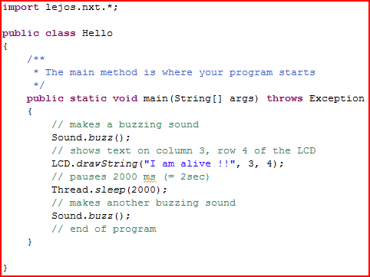
Java Programming Language

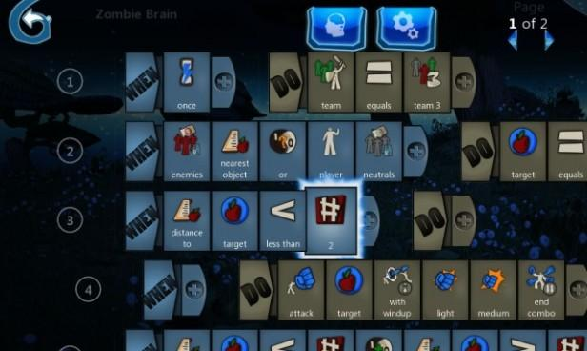
Project Spark

What is Software Development?
Now that you know what software is, we can get into how it’s created. That’s called software development. It’s the process used by a company, team or individuals to create a new software program. However, it can be much more involved than it seems. There is a lot of planning and designing that happens before anyone starts to write code. There is also testing, documenting, bug fixing and releasing to customers that happen along the way. All of these steps together are called the software development life cycle and is necessary to creating any type of software.
The steps involved in the software development life cycle don’t really change much. How those steps are executed can vary depending on the type of software, the consumers who will use it, or team preferences. Some of the more popular variations include Waterfall and Agile, but also include other less popular techniques such as Prototyping, Spiral, Incremental, and others. In this course we will focus on Agile, which will be described in more detail later on. For now, here’s an overview of some of the others.

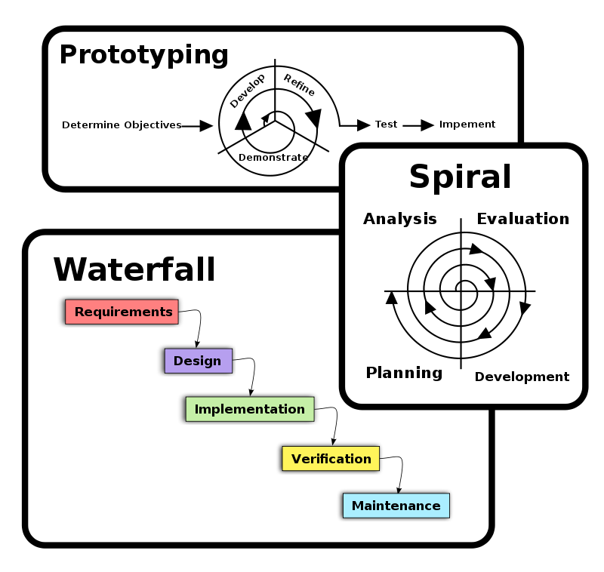

What is Agile?
The art of creating apps, games and other software has changed quite a bit in recent years. It used to be that you could take two years to develop something neat and only update it once a year. With the introduction of iPhones, Facebook, Xboxes and Galaxy Tabs, the competitive landscape has changed and software development has never been more accessible to people who want to create apps. Because there are so many apps out there now, people who buy apps have many choices. Not only do they expect to be satisfied instantly without spending a lot of money, they also expect a steady stream of new features and updates. Imagine if you bought Angry Birds Star Wars and didn’t get a single new level until a year later. Until recently, that was expected from software. In order to adapt to the changing buying and playing behaviors of people, a new way of creating software had to emerge: agile development.
Agile development is a way of managing teams that are responsible for creating software and the associated projects. It was founded on four important values:
- Focusing on interactions with people instead of strict processes and tools
- Creating software that works instead of comprehensive documentation
- Collaborating and designing software with customers instead of focusing on negotiating contracts
- Responding to frequent changes instead of following a plan

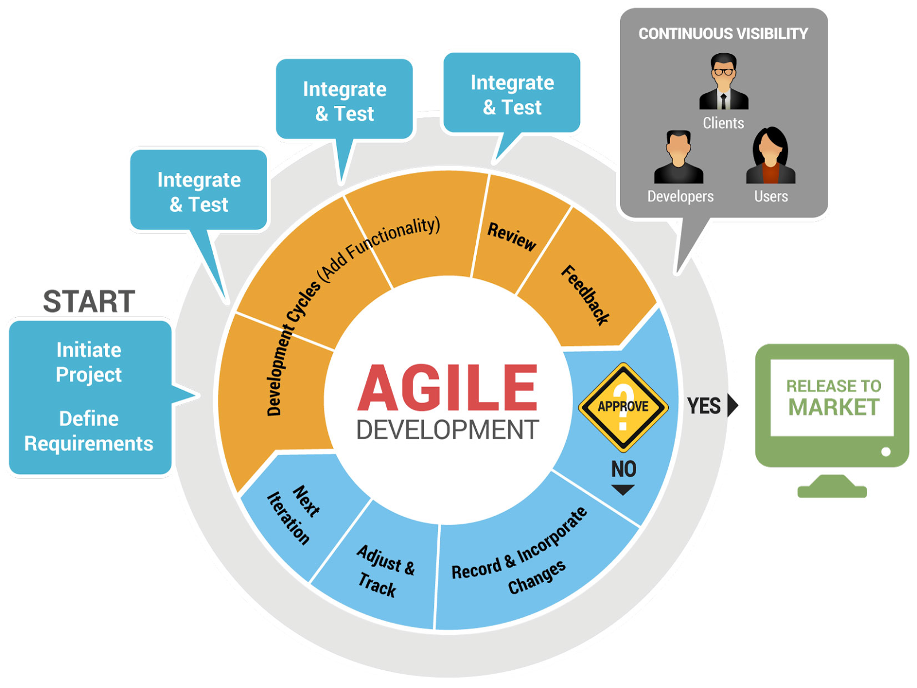

Designing and creating apps is never done the same way twice and every team always has their own flavor of agile. However, there are some key principles that all agile teams should think about.
- YOU MUST BE INVOLVED. This is the most important principle. Become an active participant, throw out ideas and talk to your team. Discuss issues and brainstorm face-to-face. It’s your responsibility to help the team in any way you can.
- A team must be empowered to make decisions. Agile teaches you to make decisions based on the information you have at that time. Don’t be afraid of making mistakes. If a choice turns out to be the wrong one, adapt quickly and decide on a new action.
- What your app does may change over time, but the day it releases to customers does not. Be prepared to drop features to make your deadlines.
- Develop small, incremental releases. Don’t try to put too many features into a single release. This keeps your customers happy because they see new things more often.
- Test early and often. Testing should be integrated into the development of your app. As you get new features done, they should be tested immediately.
- Complete each feature before moving on to the next. The team should always be focused on one collective goal at a time.
- Business people, developers and other stakeholders need to work together on a daily basis.
- Periodically reflect on how your team is doing, what can be done to become more effective, and adjust how you do things accordingly.

Designing Your World
Some applications like games and websites have lots of images, graphics and animations. These are created by designers who take their artistic creativity to bring an idea or world to life. Depending on the software, different types of designers may be needed. A website needs a graphic designer to draw icons, images and design page layouts. A 3D action video game needs a 3D graphics designer or 3D modeler to create an entire world from scratch. This could include anything from people to mountains.

Role Responsibilities in Intro to App Development
- Build the landscape for your game. This could include mountains, rivers, trees, tunnels and more.
- Decide the time of day, where the sun should be, and any backdrops that should be used.
- Choose and design the hero, enemy and other characters. Some characters can be customized to your team’s liking.
- Create animations for the characters and objects in the world.
- Decide where the camera should be at all times during your game.
- Add the user interface to display the score, health, time, objects carried, or any other key piece of information the player needs to know.

Jobs for Designers:
Website Graphics Designer, Creates images, icons and logos for a website.
Game Level Designer, Designs worlds for video games.
User Experience Designer, Creates designs and layouts of applications to make it easier for people to understand and use.
User Interface Designer, Designs the parts of an application that require people to interact with it.
Animation Artist, Creates 2D or 3D animations for websites, video games, TV or movies.
3D Modeler, Responsible for creating 3D representations of items such as cars, people, roller coasters and video game objects.
Architect, Plans, designs and oversees the construction of buildings.

Interface for Building Your World

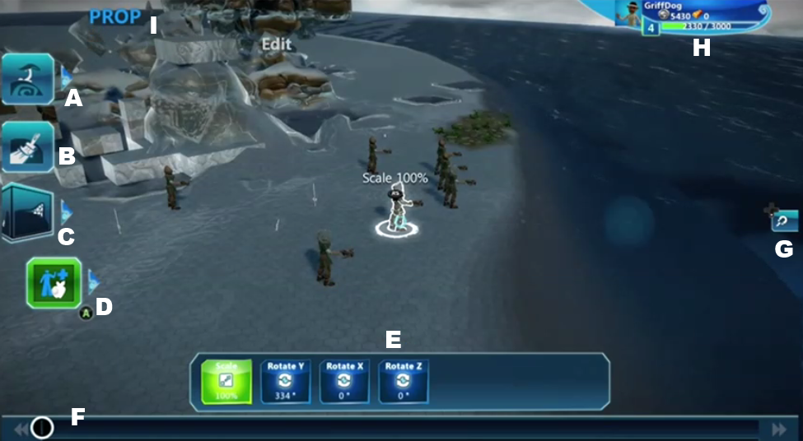

Paint is the default mode you start in. This details the default/paint UI in Create Mode.

A: Biome Tools – Select the arrow to slide out toolbar for more Biomes.
B: Paint Tool
C: Terrain Tools – Select the arrow to slide out toolbar for more Terrain Tools
D: Props & Edit – Select the arrow to slide out toolbar for more Prop & Edit Tools
E: Tool Bar
- This allows you to change the palette between material, prop, shape, and intensity controls depending on the brush or tool selected.
F: Undo Track
G: Grid Snap On/Off toggle
H: Xbox Gamertag
I: Name of currently selected Tool

Biomes
Allows you to create things in an all-in-one brush.
Nature - Place trees, wildlife, foliage, and more in one simple swipe.
Rivers - Create rivers and sea beds in one swipe.
Erase - Paints an “empty” material over your paint and deletes biome props.

Paint
Bring color to your world. Create grass, paths, ice, and more.
- Paint automatically sticks around surface edges.
- Paint naturally applies based on the surface you are painting. There are 3 types of surface paint:
  - Ground
  - Sides
  - Ceilings

Scale (Brush Size)
While in Paint mode, Press LB, select Scale with the Left Thumb Stick, and while holding LB, move the Right Thumb Stick left or right to change the size of the brush.

Change Brush Shape (Also Applies to Sculpting)
This controls the shape of the brush. While in Paint mode, Press LB, select Shape with the Left Thumb Stick, and while holding LB, move the Right Thumb Stick left or right to change the shape of the brush to circle, cylinder, or square.

Intensity
This controls how fast you fill an area with paint, which can be handy when mixing materials. While in Paint mode, Press LB, select Intensity with the Left Thumb Stick, and while holding LB, move the Right Thumb Stick left or right to change the intensity of the brush.

Change Materials
Press the Directional Pad left or right to select a material on the bottom Material bar. Press the Directional Pad up to enter the material gallery for more materials.

Erase
You have two ways to erase:
- Use an “empty material” as a paint brush.
- Select Erase in the Biome Brush, though this will also remove props added by a Biome Brush.
Note – While not really erasing, you can always use the undo track by pressing the View button.

Sculpt
Sculpt your terrain to do things like create mountains, rivers, platforms, tunnels, and more. The world is like your clay block to mold!
There are several different ways to alter the terrain, as detailed below. Generally the first 2 (Expand/Erode and Add/Subtract) are used to build up/out your world. The additional 3 tools are used to alter or fine tune your landmass.
Note – The mode of the function is determined by using the Left or Right Trigger.

Expand/Erode
This is a key terrain brush that can be very flexible and do a lot of things.
- +Expand – “Pulls” the selected area to create elevations. Use the Right Trigger for this.
- –Erode – “Removes” the selected area to create indents and deposits. Use the Left Trigger for this.
- Example Use:
  - Create mountains with Expand
  - Create hills and bumps with Expand
  - Create gullies and indents with erode
  - Create troughs/rivers with erode (if dug deep enough)

Add/Subtract
This is an advanced, but more precise way to add and remove terrain. Instead of pulling like erode, this tool actually adds in the shape of the selected brush.
- +Add – Adds terrain to your world in the shape of the selected brush. Use the Right Trigger for this.
- –Subtract – Physically removes terrain in your world in the shape of the selected brush. Use the Left Trigger for this.
- Example Use:
  - Create strips or platforms with Add (when horizontal)
  - Create pillars or terrain (when vertical) with Add
  - Create walls with Add
  - Remove sections or carve out sections/chunks with Subtract

Smooth/Roughen
Smooth and roughen are great tools to use after you’ve constructed your landmass. They allow you to fine tune the terrain and edges.
- +Smooth – Makes the area selected smoother. Use the Right Trigger for this.
- –Roughen – This sharpens or roughs up the area selected. Use the Left Trigger for this.
- Example Use:
  - Smooth out surfaces to make them easy to traverse with smooth.
  - Highlight edges with roughen.

Plateau/Tunnel
Plateau and tunnel are great ways to alter your terrain and create bridges, tunnels, and platforms for level design.
- +Plateau – This takes the highest point in the terrain within your cursor and then matches wherever you select (drag around the cursor) to that new height. Basically this quickly creates platforms and allows you to connect land forms (bridges). Use the Right Trigger for this.
- –Tunnel – This is the opposite of plateau. Basically, this takes the lowest point within the brush and then flattens the terrain with the brush to bore tunnels or flatten an area. Use the Left Trigger for this.
- Example Use:
  - Flatten out surfaces in a uniformed height with Plateau.
  - Create platforms with Plateau.
  - Decrease surfaces in a uniformed height with Tunnel.
  - Create tunnels with Tunnel. (Do this by starting at the low point and pushing the cursor straight through the mountain/elevation you wish to tunnel through.

Cubify/Decubify
While more of a novelty tool, Cubify turns the world into blocks creating both a unique look and an instant platform game.
- +Cubify – Turns all terrain in the selected area into cubes. Use the Right Trigger for this.
- –Decubify – Restores all terrain in the selected area to the normal state. Note – Decubify does nothing on normal (non-cubified) terrain. Use the Left Trigger for this.
- Example Use:
  - Make an instant platform game with Cubify.
  - Turn the world into cubes with Cubify.
  - Return the terrain to its normal state with Decubify.

Props and Editing
This is the core mode relating to objects in the game (referred to as Props). Props are anything from characters and houses, to rocks and plants, to explosions and sound effects.
In addition to some advanced features, you can do two very important things from this tool:
- Place Props in the world
- Edit Props, which includes “entering” the prop to program (referred to as Kode) objects. Koding props allows you to add game play control, AI, and lots more to any object.

Placing Props
- Select the Edit Prop to enter Prop mode.
- Press Left or Right on the Directional Pad to select a prop from the bottom Prop bar.
- Or press Up on the Directional Pad to open the Prop Gallery and select from a wide variety of Props.
- Once you’ve selected a Prop, simply press Right Trigger anywhere on the screen you wish to place it.
- To snap a Prop to the ground, press Left Trigger.
- Notice that the prop is added to the prop bar to make it easy to add additional copies.

Moving/Editing Props
Select the Prop you wish to edit by moving over it and holding the LB button. A series of “widgets” in the form of icons and arrows will appear around the Prop after selecting it.

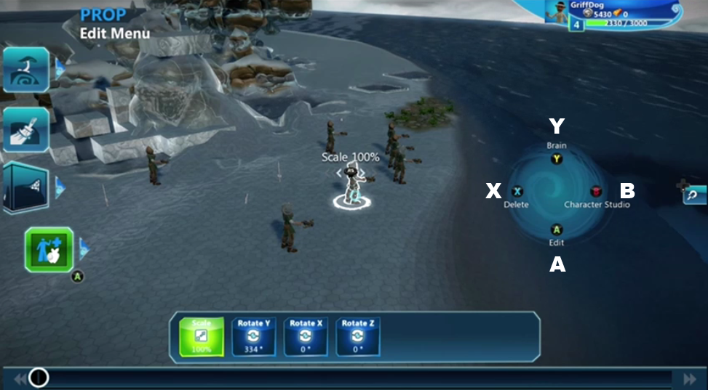

Here you can do the following:
- Y – While holding LB, press Y to enter the Brain Editor. The Brain Editor allows you to Kode. See Brain Editor section below.
- A – While holding LB, press A to enter the Prop’s Properties. Here you can:
  - Enter the Brain Editor
  - Alter things like color, physics, health and damage properties and more!
  - Clone (copy) the Prop.
  - Swap the Prop’s mesh (turn a bird into a fish!)
  - Delete the Prop
- B – Press B to open the Character Studio to change clothing, colors, and attachments
- X – Press X to delete the Prop.
- Press Right Trigger over the Prop and use the Left Thumb Stick to move the object around.
  - To move the Prop up, press Y while moving the object around.
  - To move the Prop down, press X while moving the object around.
- To increase and decrease the Prop’s size, hold LB over the Prop, move the Left Thumb Stick to Scale, and while holding LB, move the Right Thumb Stick left or right to change the scale.
- To rotate the Prop, hold LB over the Prop, move the Left Thumb Stick to Rotate X, Rotate Y or Rotate Z, and while holding LB, move the Right Thumb Stick left or right to change the Prop’s direction.
Note – You can always click Left Trigger to “resnap” that object to the ground. If Left Trigger is held while moving the Prop, it will stay snapped to the ground.

Quick Help Guides for Designers

Paint Something
- Press A and select the Paint icon on the Left Side of the screen.
- Hold Right Trigger on the area(s) you wish to paint in.

Sculpt the Terrain
- Press A and select the Terrain Tools icon on the Left Side of the screen.
- Use the default Expand/Erode or choose other sculpting tools.
- Hold Right Trigger on the area(s) you wish to Sculpt in.

Change Brush Shapes
- Select a valid Brush (Biomes, Sculpt Terrain, Paint)
- Hold LB to bring up the options bar.
- While holding LB, use the Left Thumb Stick to select Shape.
- While holding LB, use Right Thumb Stick to select your Brush Shape.

Choose Paint Materials
- Select the Paint icon on the Left Side of the screen.
- Select any of the materials in the material bar on the bottom of the screen by touching or clicking the cube with the material picture.
- To swap out for more materials the arrow above the bar.

Place Props
- Select the Prop & Edit icon on the Left Side of the screen.
- Select an item from the Prop Bar along the bottom of the screen by pressing Left or Right on the Directional Pad, or enter the Prop Gallery by pressing Up on the Directional Pad.
- With your item selected, press Right Trigger anywhere on the screen to place your item.

Move a Prop
- Select the Prop & Edit icon on the Left Side of the screen.
- Highlight the object and press Right Trigger.
- Drag the object around and press Right Trigger to place it.
- Press X or Y to move the object up and down.

Delete a Prop
- Select the Prop & Edit icon on the Left Side of the screen.
- Hold LB over the Prop you wish to delete.
- Press X to delete the Prop.

Copy a Prop
- Select the Prop & Edit icon on the Left Side of the screen.
- Press Left Trigger over the Prop you wish to copy. This clones the Prop.
- Drag the object around and press Right Trigger to place it.
- Press X or Y to move the object up and down.

Change Prop Colors
- Select the Prop & Edit icon on the Left Side of the screen.
- Hold LB over the Prop you wish to edit.
- Press A to edit the Prop.
- Now Select Properties > Appearance.
- Select the part of the object that you want to change the color on – you’ll see a preview of the current color assignment.
- Use the Left Thumb Stick and Directional Pad to change the value in the color picker.
- Press A when done.

Rotate Props
- Select the Prop & Edit icon on the Left Side of the screen.
- Hold LB over the Prop you wish to edit.
- Move the Left Thumb Stick to Rotate X, Rotate Y or Rotate Z.
- While holding LB, move the Right Thumb Stick left or right to change the Prop’s direction. Note the bending arc arrows in front of the Prop.

Scale Props
- Select the Prop & Edit icon on the Left Side of the screen.
- Hold LB over the Prop you wish to Scale.
- Move the Left Thumb Stick to Scale.
- While holding LB, move the Right Thumb Stick left or right to change the scale.

Change the Properties of Props
- Select the Prop & Edit icon on the Left Side of the screen.
- Hold LB over the Prop you wish to modify.
- Press A to edit the Prop.
- Here you can select a huge variety of properties!

Change the Physics of a Prop
- Select the Prop & Edit icon on the Left Side of the screen.
- Hold LB over the Prop you wish to modify.
- Press A to edit the Prop.
- Now Select Properties > Physics > Physics Type
  - Upright forces the Prop to “stand” and is great for characters
  - Fixed allows the Prop to fly and maintain its position.
  - Tumbling applies real physics and will cause things to bounce, roll, and tumble realistically.

Change the World Properties
- Enter the Pause Menu by pressing the Menu button.
- Select World Properties.
- From here, you can change the water level of the world, music, sun light and more!

Programming Your World
A programmer analyses, understands and solves problems with computers using step-by-step instructions called algorithms. These well-defined calculations are typically instructions that range anywhere from adding numbers to telling a character to make a sound when something hits it. Programmers use many different programming languages to create the set of instructions known as a program. Each program is designed to tell the physical hardware such as a computer exactly how it should perform. For example, programming a character to move in a video game is really just a fancy way of telling the computer to make the display redraw tiny pieces of light from one location to another. Our eyes interpret this fast redrawing as movement on the screen.

Role Responsibilities in Intro to App Development
- Give the hero, enemies and other characters “Brains” by programming them to react to buttons or situations.
- Add sound effects when characters perform actions.
- Add music when certain actions are performed.
- Change the physics or properties of characters and objects.
- Make characters and objects interact with each other.

Jobs for Programmers:
Website Developer, Creates websites.
Applications Developer, Writes applications for work or entertainment.
Game Developer, Programs video games and even the computational engines used to build video games.
User Interface Developer, Programs user interfaces that are designed by User Interface Designers.
Hardware Programmer, Creates code that runs on physical hardware like computer chips, robotics and display screens.
Scientific Programmer, Applies programming to scientific research such as bioinformatics, which is the development of methods and software tools for understanding biological data.

Brain Editor
The Brain Editor is the most powerful, but also the most complex area of Project Spark. Here you can Kode Props and bring them to life.

The Basics
Brains are made of Pages which contain lines. Lines contain 2 sides; When and Do. On these sides, Tiles can be placed. The Tiles add logic to the brains and allow you to determine conditions (When) that trigger actions (Do). A simple and fun Line of Kode would be:
When: Button A Do: Jump
This will make an object (even a rock!) Jump when you press A on the controller or virtual button.

Details

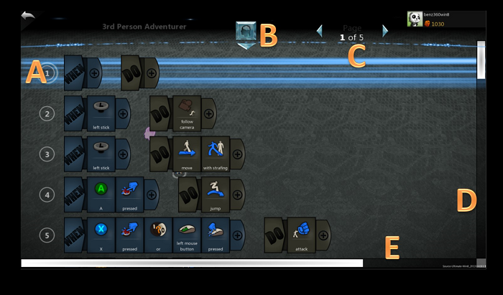

This is the general Koding screen where you can add Lines and Tiles.
Note the + next to When and Do and placed Tiles indicates that you can add more Tiles.
- A - The circle with a # indicates the “Line” the Kode belongs to. You can select a line to do the following:
  - Move lines around by pressing A on the circle.
    - Up and down.
    - Or move Right (or left) to make it a child rule to the line above.
  - Insert lines by clicking in the Left Thumb Stick.
  - Delete lines (note “child” Line will also be deleted) by pressing X.
  - Copy lines by pressing Left Trigger.
  - Paste lines by pressing Right Trigger.
Note – Making a line a Child (by indenting it from the line above) means that line will only be active once the line above completes. This is a powerful way to organize your Kode lines.
- B - This is the “Brain Button”. Press the Menu button to open the Brain Options. Here you can:
  - Enter the Brain Gallery
  - Save a Brain
  - Rename a Brain
  - Rename a Page
  - Copy a Page
  - Paste a Page
  - Delete a Page
  - Access general game options
- C - Use this to change Brain Pages.
- D - Vertical Scroll Bar
- E - Horizontal Scroll Bar

Koding
Koding may sound tricky, but it’s really not. A good way to start is by opening other Props with Brains and learn to read them. But the best way is to just try because the system of tile compatibility that means you can easily experiment. It works like this:
- There are hundreds of tiles to choose from with functions on each. Tile compatibility knows all of them and which go together!
- That means you can get put something in, click the + on the next empty tile and it will reduce your tile options to only valid ones!
- Even if you aren’t sure what you want next, it will help you, just try it!

Tile Picker Screen
This is how you choose tiles. Most tiles you will see a Folder that will open up to individual Tiles. Think of Folders as groupings of functions or concepts (Combat) and the Tiles as the individual thing in them.

To add more Tiles to your Lines, you need to Touch or Click on the + tab.
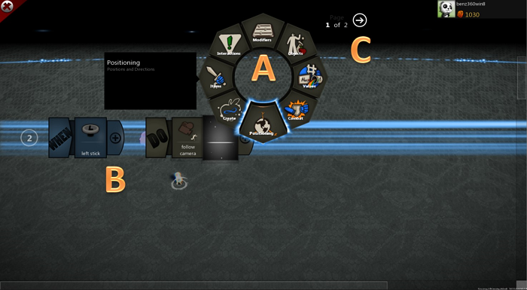

- A - This is the Tile Picker Wheel. Here you can select the Folders and Tiles you wish to place on the Lines.
- B - This shows the current Line you are working in. The users clicked to + tab after the Follow Camera Tiles and is now adding a tile after that one.
- C - This allows you to change pages in the Wheels. There’s hundreds of Tiles so if you can’t find what you want, be sure to try other pages!

Example Kode:
When Side Blank = Always
- Leaving the When side blank actually = always. It’s super easy to Kode things like this. For example:
- When: Blank Do: (press the small arrow with the circle to go to page 2) Camera Folder > Follow Camera
- And now you have a Follow Camera “Always” on that Prop!

Here are some of the more powerful and easy concepts:
When Side:
Sensors Folder > Detect
+ Objects Folder > Player
This tells any Prop that when it detects an object with game controls to do something.
Do Side:
Movement Folder > Move
+ Modifier Folder > Towards
+ Objects Folder > Player
Notice how with each + you add, your choices are limited to only valid options, that’s tile compatibility!
This line of Kode allows any Prop to run right up to you when it detects you! Pretty cool!

Here’s another
When Side:
Controls Folder > Controller > Left Stick
This allows you to assign actions on button presses (or touch events by choosing touch).
Do Side:
Movement Folder > Move
Now your Prop will move around when you use the Left Stick! It’s that easy.

Modifiers Folder
This folder is super important and if you are unsure what else you can do or just want to try new things, it’s a great folder to go into after another tile is placed. You can do amazing things from this folder.

Power
Power is a setting on every object. Many objects have built-in behaviors or brains that react to the object’s Power turning on or off.
- A door’s Power setting opens and closes it.
- A visual effect can be turned on and off by toggling its Power setting.
- The Giant Crank turns when its Power is set on.
Objects can be plugged into each other to transfer power from one to another. To connect power between objects,
- Enter Power mode by selecting the Power icon on the Left Side of the screen.
- Select the first item that you want to transmit Power from by pressing Right Trigger.
- Select the second object you want to connect Power to by pressing Right Trigger.
- You should see a line appear between the 2 objects. The direction of the flow shows how Power will flow from one object to the other. An object can receive and provide Power to any number of Props.
Breaking a power connection is easy. Simply repeat the actions you would make to connect between the two objects.
Example use:
- Place a Rustic Lever. This Prop’s default brain allows the B button to toggle its power setting.
- Place a door. This Prop opens and closes when power is on/off.
- Connect Power from the lever to the door.
- Now test and play and you can switch the lever to open the door!

Attach
This allows you to attach 2 Props together.
- Enter Attach mode by selecting the Attach icon on the Left Side of the screen.
- Select the Prop you wish to attach by pressing the Right Trigger.
- Select the Prop you wish to attach it to by pressing the Left Trigger.
- Repeat to detach.
The first object you select is called the child object. The second object is called the parent. Moving, scaling and other edits made to the parent can apply to the child but edits to a child object have no impact on a parent.

Multi-edit/Multi-select
This allows you to select multiple Props at once and is great to do things like glue them together or delete batches of Props quickly. To multi-select:
- Enter the Multi-Edit mode by selecting the Multi-Edit icon on the Left Side of the screen.
- Select each item individually by pressing the Right Trigger.
- Or hold the Right Trigger down to expand the selection area to “lasso” everything in it.
- Hold the LB button to bring up the menu of options.
- While LB is being held,
  - Press X to delete all selected objects.
  - Press Y to glue the objects together.
  - Press A to save the objects as an assembly.

Gluing versus Attaching
Gluing an object to another object is a lot like attaching. Both are good for connecting objects together. Gluing makes 2 objects act as a single object while attaching lets you group objects together but still control them individually.
- Doors, windows and walls are usually “glued” to make a house or other building.
- A turret is “attached” to a chassis so the turret can move with its body but rotate on its own.

Brain Gallery – 1 click game making!
A really easy way to make Brains is to enter the Brain mode and press the Menu button. This opens the Brain Gallery and just like the Props Gallery you can select completely functional Brains and just pop them into Props! Some sample Brains:
- Adventure Game Controls
- Shooter Game Controls
Enemies

Quick Help Guides for Programmers

Make characters move
- Select the Prop & Edit icon on the Left Side of the screen.
- Select the Prop you wish to add Brains to by holding the LB button.
- While holding LB, press Y to enter the Brain Mode.
- When: Select your event here. For example:
  - When: Controls Folder > Controller Folder > Left Stick
- Do: Add your move event
  - Do: Movement Folder > Move
- Now you can use the Left Stick to move your character.
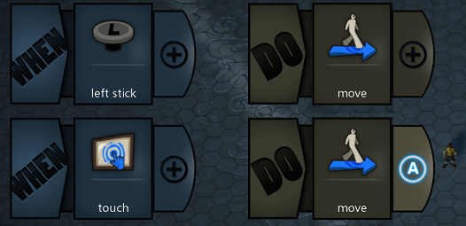

Make characters with Strafe
This is just like adding move, however you add an additional tile after move by using the modifiers folder.
- Select the Prop & Edit icon on the Left Side of the screen.
- Select the Prop you wish to add Brains to by holding the LB button.
- While holding LB, press the Y button to enter the Brain Mode.
- When: Select your event here. For example:
  - When: Controls Folder > Controller Folder > Left Stick
- Do: Add your move event
  - Do: Movement Folder > Move
  - +: Modifiers Folder > with strafing
- Now your character will move with strafing.
- Note – As you may have seen, there’s a lot of things you can do in the modifiers folder. It’s just as easy to add flying for example!
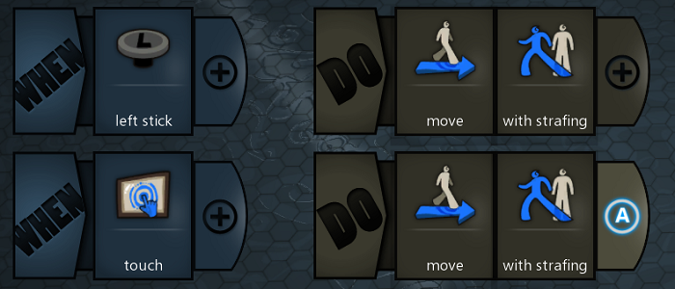

Add entire Brains to objects
- Select the Prop & Edit icon on the Left Side of the screen.
- Select the Prop you wish to add Brains to by holding the LB button.
- While holding LB, press the Y button to enter the Brain Mode.
- Press the Menu button to bring up the Brain Options.
- Select the Brain Gallery.
- Select the Brain you wish and it will load the Brains for it automatically.
- You can now Test/Play with the new Brain or edit it if you wish!

Add a Sound to a Prop
- Select the Prop & Edit icon on the Left Side of the screen.
- Select the Prop you wish to add Brains to by holding the LB button.
- While holding LB, press the Y button to enter the Brain Mode.
- When: Select your event here. For example:
  - When: Combat Folder > Combat Events Folder > Hit by Attack
- Do: now add your sound: For example:
  - Do: Create Folder > Play Sound
  - +: Objects Folder > Open Prop Gallery
- Now select your sound! Any time this Prop is hit by an attack, this sound will play.

Add an FX to a Prop
- Select the Prop & Edit icon on the Left Side of the screen.
- Select the Prop you wish to add Brains to by holding the LB button.
- While holding LB, press the Y button to enter the Brain Mode.
- When: Select your event here. For example:
  - When: Combat Folder > Combat Events Folder > Hit by Attack
- Do: now add your sound: For example:
  - Do: Create Folder > Play FX
  - +: Objects Folder > Open Prop Gallery
- Now select your FX! Any time this Prop is hit by an attack, this FX will play.

Make Enemies
The easiest way to do this is use our default Brains and modify or learn from those.
- Select the Prop & Edit icon on the Left Side of the screen.
- Select the Prop you wish to add Brains to by holding the LB button.
- While holding LB, press the Y button to enter the Brain Mode.
- Press the Menu button to open the Brain Options.
- Select the Brain Gallery.
- Select the Brain you wish and it will load the Brains for it automatically.
- Scroll through the list or search to find the Enemy Brains included:
  - Enemy Brain
  - Enemy – Scavenger Brain
  - Enemy Lights Brain

Modify a Jump
- Select the Prop & Edit icon on the Left Side of the screen.
- Select the Prop you wish to modify by holding the LB button.
- While holding LB, press the A button to enter the Properties Mode.
- Now Select Properties > Movement > Jump
- Here you can change things like height and jump count (single or double jump, etc.)

Change Movement Speed
- Select the Prop & Edit icon on the Left Side of the screen.
- Select the Prop you wish to modify by holding the LB button.
- While holding LB, press the A button to enter the Properties Mode.
- Now Select Properties > Movement
  - Here you can turn you Ground Speed.
  - Select Fly to tune flight speeds
  - Select Advanced to tune 1st person turn speeds, Strafe Speeds and use advanced scalers

Add Attack(s)
- Select the Prop & Edit icon on the Left Side of the screen.
- Select the Prop you wish to add Brains to by holding the LB button.
- While holding LB, press the Y button to enter the Brain Mode.
- Now add the following Tiles on the When Side:
  - When: Controls > Controller > X (you can use anything you wish to trigger)
  - + Modifiers Folder > Pressed (this will stop the action from repeatedly firing with a single press).
- Now add the following Tiles on the Do Side:
  - Do: Combat Folder > Attack
  - You can add more tiles to modify the attack or create a combo
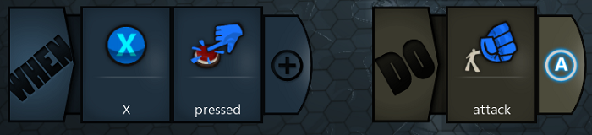

Create a Combo
- Select the Prop & Edit icon on the Left Side of the screen.
- Select the Prop you wish to add Brains to by holding the LB button.
- While holding LB, press the Y button to enter the Brain Mode.
- Now add the following Tiles on the When Side:
  - When: Controls > Controller > X (you can use anything you wish to trigger)
  - + Modifiers Folder > Pressed (this will stop the action from repeatedly firing with a single press).
- Now add the following Tiles on the When Side:
  - Do: Combat Folder > Attack
  - + Modifiers Folder > Medium
  - + Modifiers Folder > Heavy
  - + Modifiers Folder > End Combo

Shoot
- Select the Prop & Edit icon on the Left Side of the screen.
- Select the Prop you wish to add Brains to by holding the LB button.
- While holding LB, press the Y button to enter the Brain Mode.
- Now add the following Tiles on the When Side:
  - When: Controls > Controller > Right Trigger (you can use anything you wish to trigger)
  - + Modifiers Folder > Pressed (this will stop the action from repeatedly firing with a single press).
- Now add the following Tiles on the When Side:
  - Do: Combat Folder > Shoot
  - Note – you can use the Properties menu to change things like damage, speed, etc.

Shoot a Specific Object
While you can shoot a default object easily, it takes more steps to customize. This is a more advanced technique but yields greater possibilities within shooting.
- First select the object you wish to use to shoot. For example select the apple.
  - Place the Apple in the world and go into Properties < Brain
  - Turn on Template (this turns the object invisible and allows it to respawn as needed)
- Now select the Prop you want to shoot from (character for example)
  - Enter the Brain and use the Following Tiles:
  - When Side:
    - When: Controls > Controller > Right Trigger (you can use anything you wish to trigger)
    - + Modifiers Folder > Pressed (this will stop the action from repeatedly firing with a single press).
  - Now add the following Tiles on the When Side:
    - Do: Combat Folder > Shoot
    - + Objects Folder > in-world picker (this allows you to reference an in-world object)
    - Now Select the Apple you placed (your template)
    - And done!

Destroy Something in a Fun Way!
- Select the Prop & Edit icon on the Left Side of the screen.
- Select the Prop you wish to add Brains to by holding the LB button.
- While holding LB, press the Y button to enter the Brain Mode.
- Now add the following Tiles on the When Side:
  - When: Timing and Logic Folder > countdown timer
  - +: Values Folder > Number > New number
    - Enter 2 for example (this is “time”)
- Now add the following Tiles on the Do Side:
  - Do: Create Folder > Play FX
  - +: Objects Folder > Gallery Picker
    - Select Fire Explosion
- Create a new Line below.
- Select the Line by pressing the A button on the Line number.
  - Directional Arrows will appear, press Right on the Directional Pad. This indents the Line making it a “Child Rule”. This line will be called after the one above.
  - Press the A button to set the indention of the Line.
  - Now go to the Do Side in the Child Line
    - +: Create Folder > Destroy
    - Test!

Set Health Values
- Select the Prop & Edit icon on the Left Side of the screen.
- Select the Prop you wish to edit by holding the LB button.
- While holding LB, press the A button to enter the Properties Mode.
- Now Select Properties > Combat > Health and Defenses
  - Here you can select:
    - Max Health
    - Starting Health
    - Invulnerable
    - And more

Set Melee Damage Values
- Select the Prop & Edit icon on the Left Side of the screen.
- Select the Prop you wish to edit by holding the LB button.
- While holding LB, press the A button to enter the Properties Mode.
- Now Select Properties > Combat > Melee
  - Here you can select damage by attack type (Light, Medium, Heavy)

Set Ranged Damage Values
- Select the Prop & Edit icon on the Left Side of the screen.
- Select the Prop you wish to edit by holding the LB button.
- While holding LB, press the A button to enter the Properties Mode.
- Now Select Properties > Combat > Shoot
  - Here you can select Projectile Damage, Speed, and more.
- Note – Shooting and Throwing have independent settings so be mindful of which action you are using.

Change the area a Prop will Detect/See in
- Select the Prop & Edit icon on the Left Side of the screen.
- Select the Prop you wish to edit by holding the LB button.
- While holding LB, press the A button to enter the Properties Mode.
- Now Select Properties > Brain > Sensors > Show Detect Sensor or Vision Sensor
- Change the setting to True and Exit the Properties menu
- You can now see the Detect sensor range and/or the See Sensor range (depending upon which you set to True).
  - To increase or decrease the size of the sensor, press Right Trigger on the handle and move it around to change your area.
  - Press Right Trigger again to set the sensor size.

Power on a Prop
- Powering something on can do a variety of things automatically including open/close doors, spin windmills, and more.
- Select the Prop & Edit icon on the Left Side of the screen.
- Select the Prop you wish to edit by holding the LB button.
- While holding LB, press the A button to enter the Properties Mode.
- Now Select Properties > Brain
- Set Power to On

Glue Props Together
- Gluing things together allows you to assemble Props and make them function as one thing. You can even add Brains to this new object. A great example of this would be combining the house pieces in the Prop Gallery to make your own houses.
- Enter the Multi-Edit mode by selecting the Multi-Edit icon on the Left Side of the screen.
- Select each item individually by pressing the Right Trigger.
- Or hold the Right Trigger down to expand the selection area to “lasso” everything in it.
- Hold the LB button to bring up the menu of options.
- While LB is being held, press Y to glue the objects together.

Unglue Props
- Select the Prop & Edit icon on the Left Side of the screen.
- Select the Prop you wish to edit by holding the LB button.
- While holding LB, press the A button to enter the Properties Mode.
- Now Select Unglue.

Make an object move on a path
While it takes a few steps, you can make Props follow a path. This is a super powerful technique to do many things.
- Enter the Prop Gallery and find the Path Prop.
- Place it in your world.
- The Logic Cube that appears is where you control properties of you Path. Select this just like any other prop and enter properties. Select Properties > Path to change things like play once or back and forth, speeds, etc. for your path.
- Move the Path to determine your path. Place the pointer at the tiny handle at the start or end of the path and press Right Trigger. Once selected, use the Left Thumb Stick to move the path’s start or end.
- Press the B button to place the node in the new position.
- You can add more nodes to do things like turn your path by selecting the start or end and pressing the Right Trigger.
- Now you need something to follow the path. Place your Prop in the world (for example a character, but this could be anything – a rock, a box, a tree!).
- Now enter the Brains of that Prop and do the following:
  - Do Side: Movement folder > Move
  - +: Modifiers Folder, Switch to the second page of modifiers > on Path
  - +: Objects Folder > in-world Picker
    - Move the pointer over the Path.
    - Press Right Trigger to select the Path.
    - Confirm by pressing the A button.
- Now your character/Prop will move along the path.
Important Notes
- You may want to move the Prop you want on the path close to the starting cube/point of the path.
You will need to “rotate” the Prop you want on the path to the proper direction you want it to face while traveling down the path.

Testing Your World
Testers have one of the most important responsibilities in software development. They make sure that the product a customer receives is the highest possible quality. Before any product is shipped, the testers spend time trying to “break” the software, or find any problems in the code. They keep track of all of the issues found, who is supposed to fix it, and when it was fixed. These issues are also sometimes called “bugs”. Many times software is released with bugs that couldn’t get fixed in time but are minor enough that a customer won’t mind.

Role Responsibilities in Intro to App Development
- Play the game to find out what works and what doesn’t work. Try to break as many things as possible.
- Write down all “bugs” or problems in the game and who needs to fix them.
- When “bugs” are fixed, write down who fixed them. If a “bug” cannot be fixed, write down why it can’t be fixed and what the workaround will be.

Jobs for Testers
Software Tester, Finds bugs in software and helps developers make sure they fix them.
Test Automation Engineer, Creates code that tests other software for bugs and reports the results.
Performance Tester, Tests how well software works as more and more people use it.

Basic Help Guides

Enter Edit Mode
- Bring up the Pause Menu.
- Select the Edit option.

Enter Test Mode
- Bring up the Pause Menu.
- Select the Test option.

Save
This should be done from Edit Mode.
- Enter the pause menu by pressing the Menu button.
- Select Save
  - Give your level a name.
  - Take a screenshot
  - Add a description
  - Add Tags to your level
- When you are ready to Save, select the Save button.

Undo
With Project Spark, the undo track is always available so you can’t make a mistake – just roll it back.
- Press the View button to undo the previous action.
- Hold the View button and use the Right Thumb Stick to go forward and reverse on the undo bar.
- Each action has a color code on the timebar:
  - Biomes are Green
  - Paint and Sculpt Terrain is yellow
  - Prop Actions (not Brain) are Blue

Find My Character
- Hold the RB button.
- While holding the RB button, press the A button.
- If there is more than one character, keep pressing the A button until the proper character is selected.
- Note this also selects the character for moving/editing.

Add Music
- Enter the Pause Menu by pressing the Menu button.
- Select World Properties.
- Scroll down to World Music and select it (the arrow)
- Now scroll through the Gallery and select your music.

Change the Lighting/Sun Side
- Enter the Pause Menu by pressing the Menu button.
- Select World Properties..
- Here you can change the following things:
  - Visual Filter
  - Sun Brightness
  - Sun Side
  - Sun Angle

Change my Game’s Camera
It’s super easy to change your game’s camera.
- Select the Prop & Edit icon on the Left Side of the screen.
- Select the Prop you wish to edit by holding the LB button.
- While holding LB, press the Y button to enter the Brain Mode.
- Leave When Blank as that = Always
- Now add the following Tiles on the Do Side:
  - Switch to Page 2 (white Arrow Right)
  - Do: Camera Folder > Follow Camera
    - You can change this to any camera type you like.

Interface: Display something on screen
- Select the Prop & Edit icon on the Left Side of the screen.
- Select the Prop you wish to edit by holding the LB button.
- While holding LB, press the Y button to enter the Brain Mode.
- Leave When Blank as that = Always
- Now add the following Tiles on the Do Side:
  - Do: Switch to Page 2 (RB Button)
  - +: Appearance Folder > Display > display
  - +: Values Folder > Text > New Text
    - Type your message
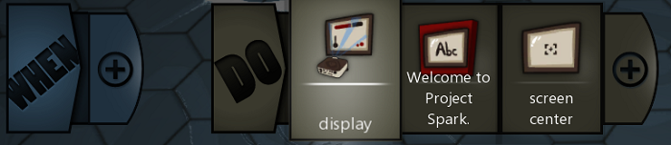
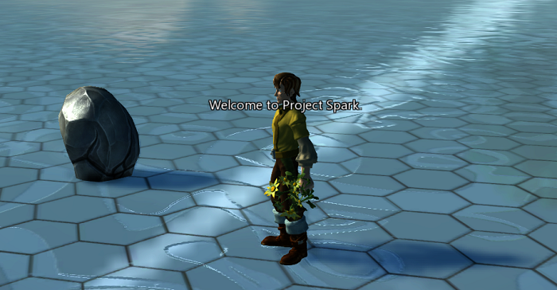
  - +: Modifiers Folder > Positioning > Screen Location > Screen Center
  - Note – Instead of text, you can use the Gallery to display icons. There’s lots of things you can display like this, experiment for cool results.
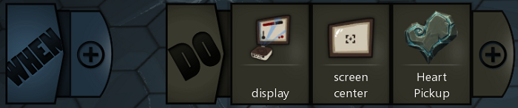
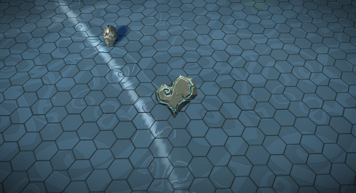

Xbox One Controller

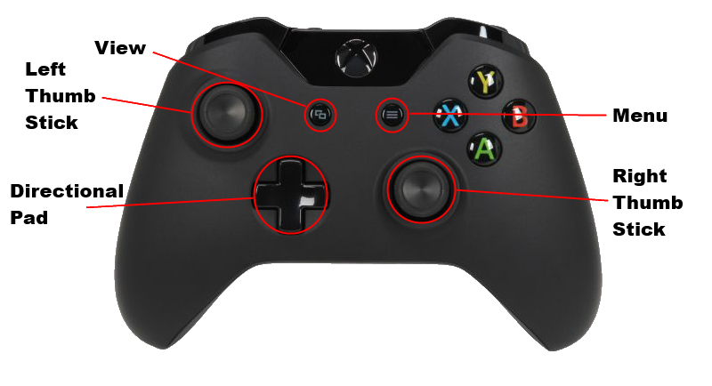
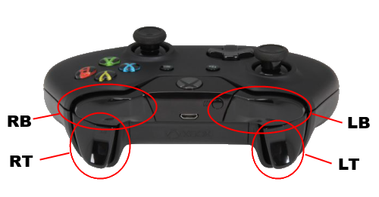

References
http://en.wikipedia.org/wiki/Software_development_methodology
http://www.allaboutagile.com/what-is-agile-10-key-principles/
http://agilemanifesto.org
http://www.projectspark.com
http://responsiveapps.us/wp-content/uploads/2013/12/Agile-Development-Diagram.jpg

