Project 1: Creating a Postcard
GET READY. LAUNCH Word if it is not already running.
1. Create a new blank document.
2. Create a custom document with a size height of 5.50 ” by 4.25 ” wide.
3. Change the document setup to landscape orientation with narrow margins.
4. SAVE the document as NAPC Postcard in the lesson folder on your flash drive.
5. Insert a header from Office.com and select Element.
6. Select the Title placeholder text and type NAPC PROFESSIONAL CONFERENCE. Change the font size and style to 14 pt bold.
7. Double-click the body of the postcard, and then type the following text:
September 14–16
Lakeview Towers in South Lake Tahoe, California
Early Bird Registration $329; Regular Rate $389
Admission to all keynotes, seminars, and breakout sessions
Ticket to Saturday night banquet
All meals included
Early Bird Deadline is August 1, 20XX
Register online at www.napc20XX.com or call 800-555-5678
8. Do not press Enter after the last line of typed text.
9. Select September 14–16, change the font size and style to 20 pt, bold, and center.
10. Select the Lakeview Towers line of text, and then change the font size to 14 pt and center the text.
11. Insert a first line indent of 0.25 ” before the E in Early Bird Registration.
12. Select the three lines of text under the registration costs information and format them as a bulleted list by selecting the solid circle.
13. Select $329. Change the font color and style to Blue, Accent 1, Darker 50%, and then bold. Change the font size to 13.
14. Use the Format Painter to copy the format of $329 and apply it to $389, August 1, 20XX, www.napc20XX.com, and 800-555-5678.
15. Select the last two lines and center.
16. Insert a 1½ pt wide box page border, using the color Dark Blue.
17. Adjust the header by dragging it below the page border. Make sure it fits on one page.
18. Create a custom diagonal watermark with the text SAVE THE DATE using the Times New Roman font, and then select the Blue-Gray, Text 2, Darker 25% color.
19. SAVE the document as NAPC Postcard Draft in the lesson folder on your flash drive.
20. Apply a page color and select Gray-50%, Accent 3, Lighter 80%.
21. Adjust the watermark and change the size to 30.
22. Your document should look similar to Figure 1. Make any necessary adjustments
Project 8-4: Creating a Chart
In this exercise, you will create a 3-D pie chart to reflect quarterly sales.
GET READY. LAUNCH Word if it is not already running.
1. OPEN a blank document.
2. SAVE the document as 8-4 Expense Report in the lesson folder on your flash drive.
3. Insert the Pie chart from Figure 8-43 into your document and format as shown.
4. Enter the data (see Figure 8-43).
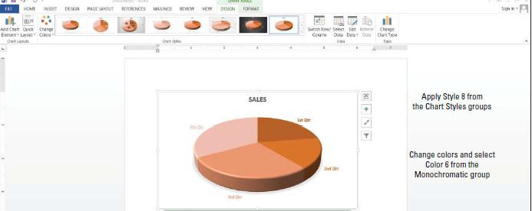
5. Insert a custom watermark and apply the image, Real Estate Folder with Data.
6. SAVE the document in the lesson folder on your flash drive then CLOSE the file.
PAUSE. LEAVE Word open for the next project.

