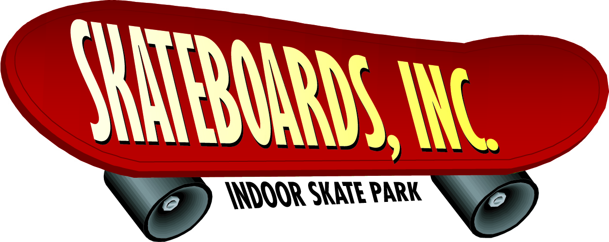
Skateboards, Inc.
Kimberly Nester, Office Specialist
360 Jackson Boulevard
Rapid City, SD 57702
Phone: 1-888-555-RAIL (7245)
Fax: 1-888-555-PIPE (7473)
Randy@skateboardsinc.net
www.skateboardsinc.net

May 15, 2010
FOR IMMEDIATE RELEASE
SKATEBOARDS, INC. ANNOUNCES THE GRAND OPENING OF ITS NEW INDOOR SKATEBOARDING AND ROLLERBLADING PARK
On Saturday, June 1, 2010, at 9 a.m., Randy Boardman proudly presents the Grand Opening of Skateboards, Inc., a new and exciting indoor skate park that has ramps, rails, quarter pipes, a fun box with stairs, and everything a skateboard enthusiast or rollerblader could ask for. “Having an indoor park will allow our patrons to have a safe, entertaining area to congregate and burn off energy any time of the year,” said Mr. Boardman.
Skateboards, Inc. consists of more than 30,000 square feet of skateboard and rollerblade ramps and includes a D.J. booth, large screen TVs, a food court, a lounge area, and arcade, lockers, and a pro shop.
The day will be filled with fun, food, and entertainment. Leslie Maddexten and Amy MacDonald (pro skateboarders) will be available to sign autographs. Each will give a short demonstration at various times throughout the day of how to use the different ramps, rails, and pipes within the facility. Our staff will also be available to conduct tours and answer questions regarding membership or any other questions you may have.
Come in and join the fun, and register to win one of the many prizes being given away, including a free one-year membership. For more information, call Skateboards, Inc. at 1-888-555-RAIL (7245).
###

