- Blubbr
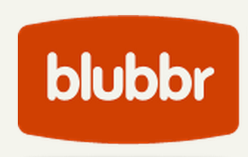
Blubbr is a cool web tool that allows users to create quizzes around YouTube videos. These are basically interactive video quizzes ( called Trivs ) that you can create for your students and which they can answer while they watch the selected video clip. The quizzes are also feedback supported meaning students will get feedback as they answer each question.
2- Teachem
Teachem is a web service that allows teachers to create lessons around YouTube videos. They can also interact with videos through adding comments, questions and notes in the form of flashcards that can be pinned to videos.
3- Educanon
Educanon is another powerful tool that teachers can use to design lessons based on videos from both YouTube and Vimeo. And like Teachem, teachers can generate questions on the content of videos and share it together with videos in a single lesson.
Tutorial
4- VideoNotes
VideoNotes is a free web tool that allows students to take notes on a video they are watching. The notes are synchronized with the video being watched. The good thing about VideoNotes is that it is integrated into Google Drive which means that students will be able to save their notes directly to their Drive account and access, edit, and work on them anytime they want. All the notes are time-stamped.
Tutorial

5- TED Ed

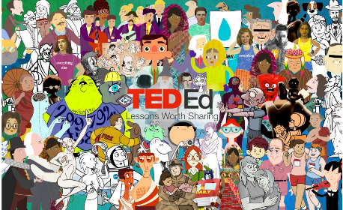
TED Ed is a website that allows teachers to create lessons around YouTube videos. Teachers can select YouTube videos and use their URLs to add questions in different formats. The added value of this tool is that it has a section where teachers can track stats of how many has answered answers and hoa mnay students have seen the lesson. Check out this visual guide to learn more about how to created a video lessons using TED Ed.

6- Vialogues
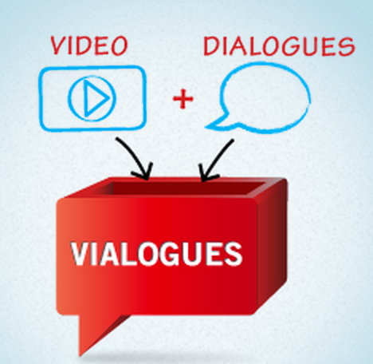
Vialogue (Video + Dialogue ) is an online video with a group discussion feature. Vialogue allows users to interact with videos by adding time stamped comments to them. This can be a great tool for teachers to use with their students to get them engaged in video prompted discussions.To get started, upload a video, grab one from YouTube, or choose one from the growing collection on our site. Once you’ve created a vialogue, you can encourage thoughtful conversations by posing questions, adding polls, and replying to comments. You can even embed a vialogue into your website, LMS, or blog!
Tutorial

7- Pontoon Edu

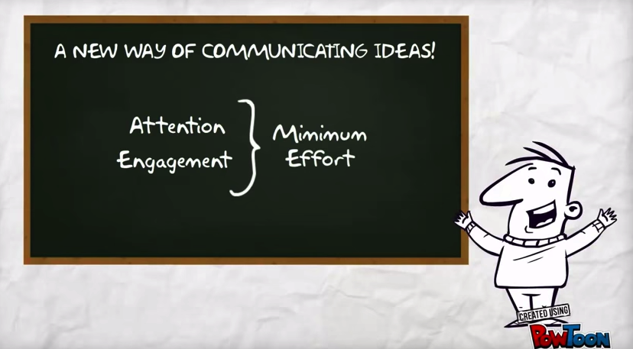

Pontoon Edu allows you to animate difficult topics and engage your students using a wide variety of tools. You can easily drag and drop characters and props into your slides and assign it an animation, choose from different pre-designed templates and style libraries.Videos and animated presentations you create through PowToon Edu can be exported in various ways. You can share them on YouTube or Facebook, download them to your computer. You can also export them as MP4 file to embed in your classroom blog or website.

8- Blendspace
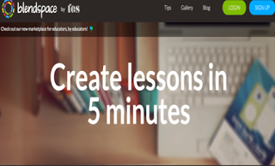
Blendspace is an excellent free tool to create flipped lessons for your class. You can create a class on Blendspace and invite up to 35 students to join it. The maximum number of active lessons you can have for free is 100. Besides sharing lessons with the class, you can also use it to collect web sources in a single place that you can share with students with just one link.

