Students will complete a
- colleague of their goals and future options.
  - Listed below are choices for career, housing, transportation, Leisure options.
  - Include insurance (renters, automobile), grocery, utility (electricity, water)
  - Other/Miscellaneous expenses (Cable, Cell Phone, …)
  - Print out (LJ printer ) put you names at the bottom right hand corner ( - 15 pts)
- budget of their monthly expenses.
  - Select a bank
    - Open a checking account to pay your bills.
    - All of your bills are due by: Dec. 14, 2016.
    - All checks should be written and given to Ms. Blount by the end of class.
    - Print Budget
    - Put your name in the top right hand corner ( - 15 pts)
    - Print out (LJ printer)

Select your housing preference
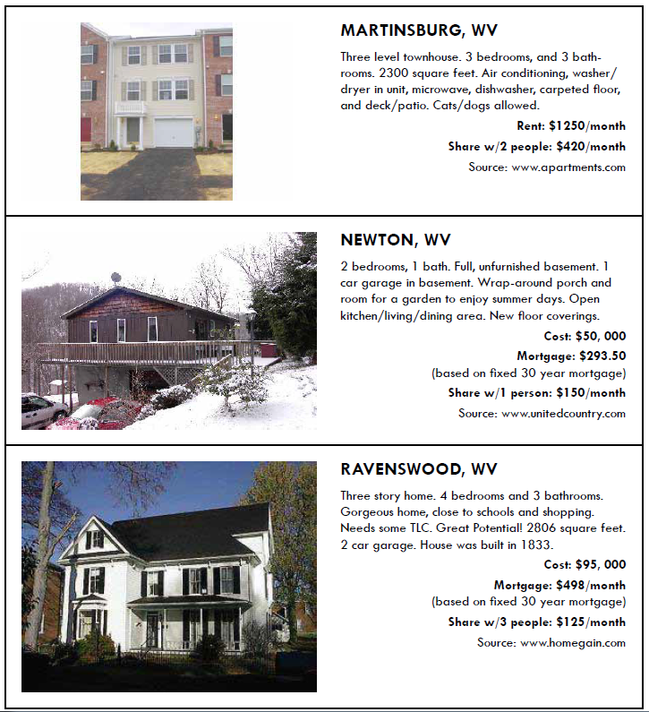

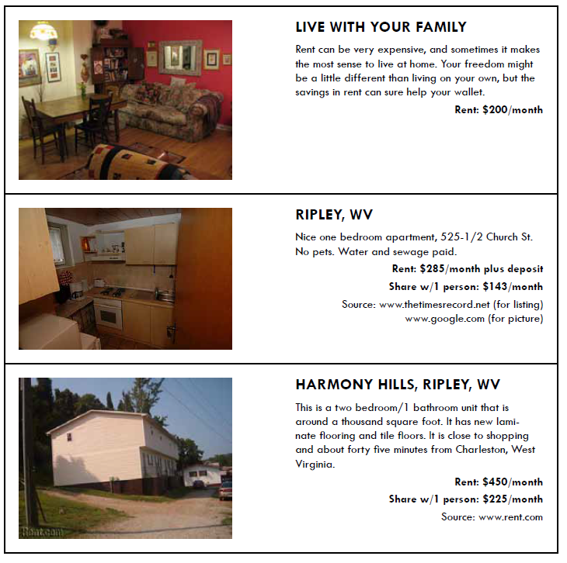
Select your Occupation/ Job
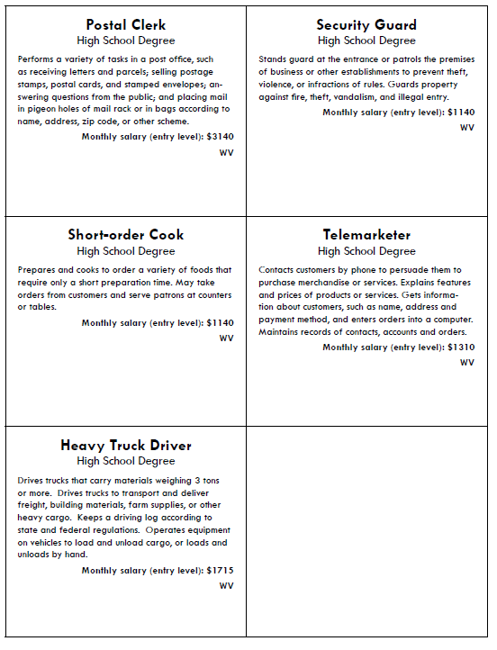

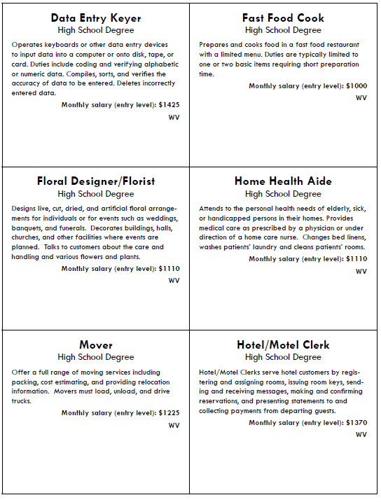

Transportation Options
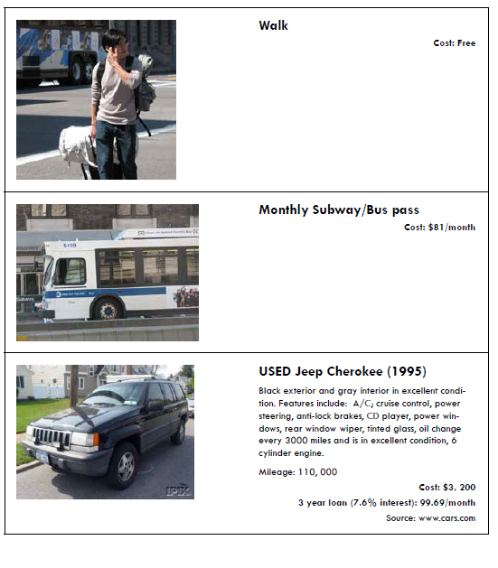

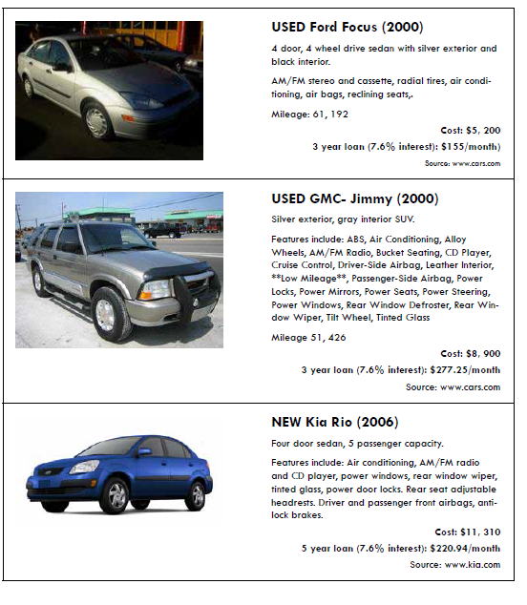

Leisure
