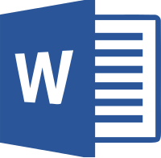
MOAC Microsoft Word 2013

Lesson 14 – Advanced Options

Directions: Open Chapter 14 of the MOAC Word 2013 textbook. Complete the sentences by finding the missing words in the section content.

  - Customizing Word
- Word can be customized through the different options available in the ______ ___________ dialog box.
  - Personalizing Word
- In previous lessons, you open the Word Options dialog box in ______________ and change the default settings. The ___________ settings contain some of the most frequently used options that can be customized in Word, including options to _________________ Word, such as changing the user name and initials.
- The more familiar you become with the options available, the _________ ______ you will be to customize Word to suit your needs.
  - Changing Display Options
- The ___________ screen of the Word Options dialog box contains options for changing how document content is displayed both on the _________ and when ___________.
- Changing these options affects _____ documents, not just the document that is currently open.
  - Turning AutoFormat Off or On
- When _______________ ___ _____ ______ options are turned on, Word allows you to apply formatting quickly as you type ___________ and number ________, ____________, numbers, borders, ____________, and hyphenate text.
- Other options that you have available are ________ ___ _____ ______ and _________________ ___ _____ ______. When the automatic formatting has been applied, you can undo the changes by using the AutoCorrect Options button in the AutoCorrect dialog box.
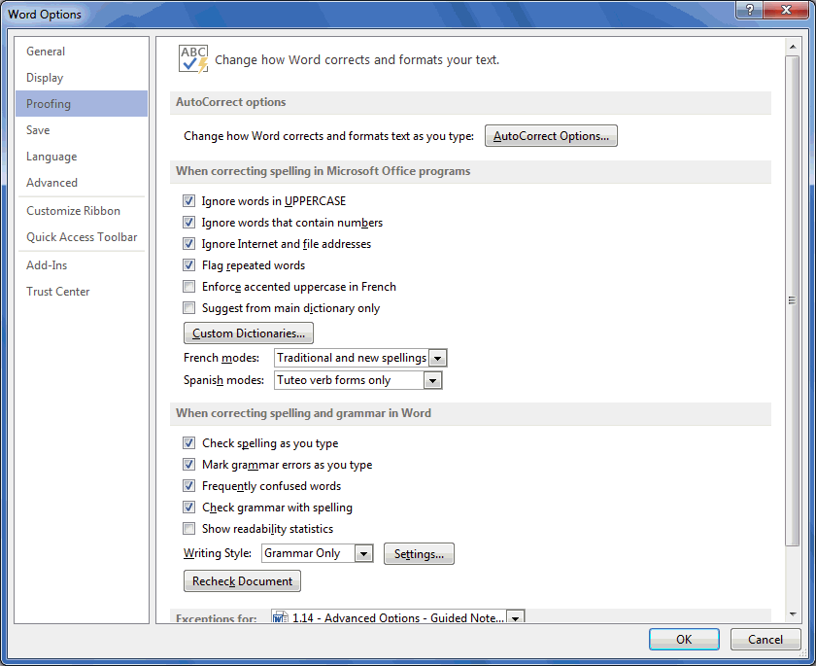
- You can access AutoFormat As You Type by opening the Word Options dialog box and selecting ____________. Then open the _______________ dialog box.
  - Setting Save Options
- The ______ screen of the Word Options dialog box contains options for customizing how documents are saved, including preserving information in _________ files for your documents, ___________ files using a document management server, and embedding ________ in a file.
  - Using Advanced Options
- The ____________ screen in the Word Options dialog box contains many complex choices for working with Word documents, including options for ___________, displaying, printing, and _________.
  - Customizing the Quick Access Toolbar and Ribbon
- The ______________ _________ and ________ _________ ___________ screens enable you to customize the Quick Access Toolbar, the Ribbon, and ____________ ______________.
- Adding frequently used commands to the Quick Access Toolbar ensures that those commands are always just a _________ click away.
- Only ____________ can be added to the Quick Access Toolbar.
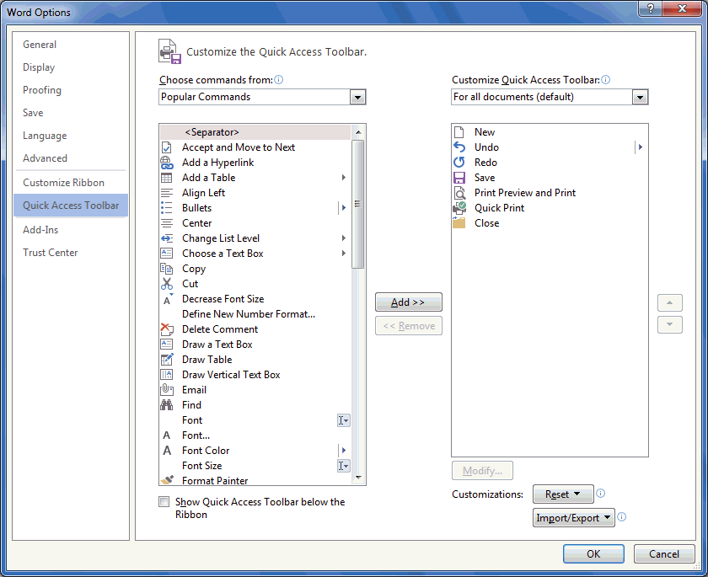 | 