Course: | BF10: Principles of Business and Finance
Objective: | NC CTE 4.02: Implement purchasing activities to obtain business supplies, equipment and services. (OP:015, OP LAP 2) (OP:016) (OP:031)

Unpacked Content
- The nature and scope of purchasing (OP:015, OP LAP 2) (CS)
  - Activities involved in purchasing
  - The purchasing process used by businesses to obtain materials, equipment, and supplies used in their operation.
- Place orders/reorders (OP:016) (CS)
  - Factors to consider when placing orders/reorders.
  - Components of purchase orders.

Course: | BF10: Principles of Business and Finance
Objective: | NC CTE 4.02: Implement purchasing activities to obtain business supplies, equipment and services. (OP:015, OP LAP 2) (OP:016) (OP:031)

Key Terms
Key Term | Definition
Purchasing | The buying of goods and services for a business. (OP LAP 2, OP LAP 3, OP LAP 5)
Purchasing Order | The form that a business fills out to order goods; may be the same as a purchase agreement or purchase contract. (DS LAP 5, OP LAP 2)
Purchasing Process | A series of sequential steps taken by purchasing specialists to buy goods and services for a business. (OP LAP 2)

4.02 The Purchasing Process Graphic Organizer
Directions: Complete the following Graphic organizer while teacher discusses the purchasing process.
Purchasing Cycle

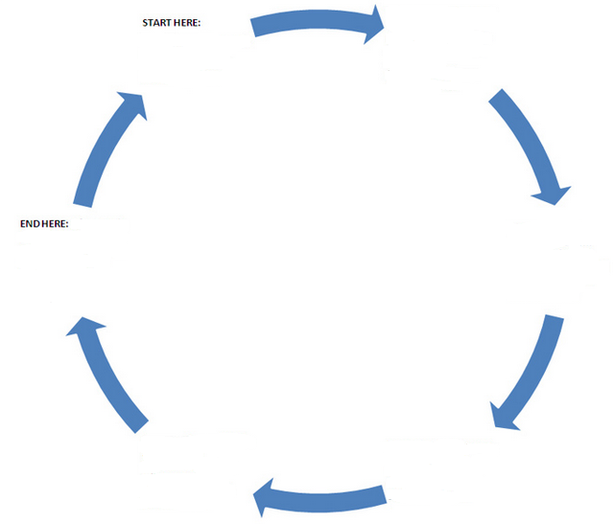

Based on the class discussion answer the following:
- In your own words, define purchasing.

- Explain the impact of effective purchasing on an operation’s cash flow.

- List and briefly explain five activities for which a purchasing department normally has responsibility.

- Briefly list and discuss two problems that a purchasing department sometimes has in meeting objectives.

4.02 Filling out a Purchase Order Instructions

How to Fill Out a Purchase Order Form:
Listed are the standards components of a purchase order. Purchase orders are often required by sellers to clearly outline the intentions of a buyer and confirm availability, price, etc., of goods. Before completing a purchase order, let’s find out more about the use and function of a purchase order.

What Is A Purchase Order Form?
A purchase order is a business form that initiates a purchase between businesses – buyer and seller. The required information to correctly complete a purchase order is relatively simple. Basically, the form is an agreement for a buyer to purchase goods or services from a seller according to pre-arranged conditions, if applicable. The purchase order may be used later to match up to an invoice to ensure accurate payment.

Components of a Purchase Order:
- Contact Information: Name and contact info for the individual submitting the purchase order, such as email, phone and fax number.
- Purchase Order #: A buyer will typically generate a unique purchase order number as a point of reference for a specific order.
- Vendor ID: If known, a seller may include a vendor ID number, which may allow the seller to more easily confirm the purchaser and complete the order.
- To: Complete address information of the seller, which may specific to the purchasing department or individual handling purchasing responsibilities.
- Ship/Bill To: Complete address information for the purchasing business, which may identify where the goods will be shipped to.
- Date: The date the purchase order was completed and submitted.
- Date Required: Date the goods/services are needed by.
- Ship Via: Preferred method for shipment/transportation of goods to be received.
- Terms: Timeframe within which payment is due. Net 30 (30 days) is common.
- Item & Description: Provide details, including the supplier’s item number and any details to ensure accurate ordering.
- Price, Quantity & Totals: List the price and quantity of each item to determine totals to ensure agreed upon pricing is accurate and set prior to purchasing.
- Notes: List and special needs or requests to the seller.
  - Calculating a Reorder Point (page 1)

The reorder point (or reorder level) is the inventory level at which a company would place a new order or start a new manufacturing run.
The following two formulas are used for the calculation of a reorder point or level
for maximum daily or weekly or monthly usage × Lead time and a reorder level for maximum daily or weekly or monthly usage × Lead time + Safety stock.
#1 Formula for Reorder Point (Level) = Lead Time x Daily Average Usage
- Lead time is the time it takes the supplier or the manufacturing process to provide the ordered units.

- Daily average usage is the number of units sold (or used) on a daily.
Example:
ABC Ltd. is a retailer of footwear. It sells 500 units of one of a famous brand daily. Its supplier takes a week to deliver the order. At what quantity should the inventory manager place his/her next order?

The inventory manager should place an order before the inventories drop below 3,500 units (500 units of daily usage multiplied with 7 days of lead time) in order to avoid a stock-out.

#2 Formula for Reorder Point (Level) with Safety Stock= Lead Time × Daily Average Usage + Safety Stock

If a business is holding a safety stock to act as buffer if daily usage accelerates the reorder level would increase by the level of safety stock.
Example:
ABC Ltd. has decided to hold a safety stock equivalent to average usage of 5 days. Calculate the reorder level.

Safety stock which ABC Ltd. has decided to hold equals 2,500 units (500 units of daily usage multiplied by 5 days).
In this scenario reorder level would be 6,000 units (2,500 of safety stock plus 3,500 units based on 7 days of lead time).

4.02 Calculating a Reorder Point (page 2)

Directions: Solve the following two problems

Problem 1:
Maximum daily requirement | 800 units
Time required to receive emergency supplies | 4 days
Average daily requirement | 700 units
Minimum daily requirement | 600 units
Time required for refresh supplies | One month (30 days)

Calculate reordering point:

Problem 2:
Two types of materials are used as follows:  Minimum usage | 20 units per week each
Maximum usage | 60 units per week each
Normal usage | 40 units per week each
Re-order period or Lead time  Material A:  Material B | 3 to 5 weeks  2 to 4 weeks
Calculate reorder point for two types of materials:

______________________________________________________________________

Use the Inventory Reorder Point Calculator at http://www.danielsoper.com/fincalc/calc.aspx?id=29 to confirm your answers.
Adapted from http://accountingexplained.com/managerial/inventory-management/reorder-level

4.02 Calculating a Reorder Point KEY (page 1)
The reorder point (or reorder level) is the inventory level at which a company would place a new order or start a new manufacturing run.
The following two formulas are used for the calculation of a reorder point or level
for maximum daily or weekly or monthly usage × Lead time and a reorder level for maximum daily or weekly or monthly usage × Lead time + Safety stock.
#1 Formula for Reorder Point (Level) = Lead Time x Daily Average Usage
- Lead time is the time it takes the supplier or the manufacturing process to provide the ordered units.

- Daily average usage is the number of units sold (or used) on a daily.
Example:
ABC Ltd. is a retailer of footwear. It sells 500 units of one of a famous brand daily. Its supplier takes a week to deliver the order. At what quantity should the inventory manager place his/her next order?

The inventory manager should place an order before the inventories drop below 3,500 units (500 units of daily usage multiplied with 7 days of lead time) in order to avoid a stock-out.

#2 Formula for Reorder Point (Level) with Safety Stock= Lead Time × Daily Average Usage + Safety Stock

If a business is holding a safety stock to act as buffer if daily usage accelerates the reorder level would increase by the level of safety stock.
Example:
ABC Ltd. has decided to hold a safety stock equivalent to average usage of 5 days. Calculate the reorder level.

Safety stock which ABC Ltd. has decided to hold equals 2,500 units (500 units of daily usage multiplied by 5 days).
In this scenario reorder level would be 6,000 units (2,500 of safety stock plus 3,500 units based on 7 days of lead time).

4.02 Purchasing Plan Activity

Working with a partner, you will plan out the purchasing of a lunch meal for your school’s cafeteria. Read over the information found in the National School Lunch Program fact sheet to familiarize you with requirements for meeting the NSLP standards. You are allowed to spend up to $3.50 per student. This will include all the components of a nutritious meal with required portions of protein, fruit and vegetables.
- Go to http://supplychain-mechanic.com/?p=43 to review an example of the purchasing process, then determine the following:
- The approximate number of students, faculty and staff you are feeding.
- The allotted budget
- The unit costs of menu items including shipping and tax
- The suppliers and distributors
- The price comparison (per unit)
- The payment terms
- Scheduled delivery
- Nutritional guidelines
- Take into consideration non-allergenic food items

- Complete POs for all items (one PO for each vendor) using a template in Word, or the www.Purchaseordertemplate.org

- Print the purchase order for your items.

Extended Learning: Using the NSLP Fact Sheet, (www.fns.usda.gov/sites/default/files/NSLPFactSheet.pd)
how can you maximize your buying power and take advantage of reimbursements or other incentives or supports for participating in the National School Lunch Program?

