MOAC Excel Lesson 2 Guided Notes
Software Orientation
Excel’s HOME Tab
The ribbon in Microsoft Office Excel 2013 is made up of a series of each related to specific kinds of that you perform in Excel. The HOME tab, shown in Figure 2-1, contains the commands that people use the most when creating Excel documents. Having commands visible on the work surface enables you to see at a glance most asks you want to perform.

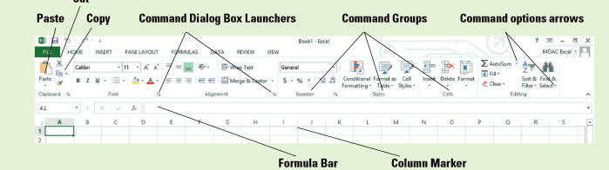

- If a command has an arrow associated with it, what does that indicate?

- What happens when you click the dialogue box launcher associated with some groups?
Creating Workbooks
- What are the 3 ways to create a new Microsoft Excel Workbook?
Saving Workbooks
- What are the two questions you must answer when saving a file for the first time?

- By default, in all Office Applications where are documents saved?

Create a folder for each lesson (Lesson 1, Lesson 2, Lesson 3, etc.) in your My Documents folder and save your files in the appropriate lesson folder.
Saving a Workbook in a Previous Excel Format
- Can files created in earlier Excel versions be opened and revised in Excel 2013?
Saving in Different File Formats
- Can you save an Excel 2013 file in a format other than .xlsx or .xls?
Entering and Editing Basic Data in a Worksheet
- You can type data ______________ into a worksheet cell or cells.
- You can ____________ and ___________ information from another worksheet or from other programs.
- What is the definition of copy?

- To enter data in a cell, the cell has to be ____________.

- What key on the keyboard to you use to move to the next column?

- What key do you use to move to the beginning of the next row?

- You can use the ___________ keys to move to an _______________ cell or ___________ on any cell to make that cell _______________.

- Which key do you press to accept the entry?

- Text is stored in only _________ cell even when it appears to ___________ into adjacent cells. If an entry is longer than the cell ____________ and the next cell contains data, the entry appears in _____________ form.
Changing the Column Width
- How is column width established?
- If you add an entry in a column that extends beyond the column’s width, it is necessary to ______________ the column width to accommodate the entry.
- How do you adjust the column width manually?

- How do you automatically adjust the column width?
Editing a Cells Contents
- To edit information in a worksheet, you can make changes __________ in the cell or edit the contents of a cell in the _____________ _________.
- Where is the formula bar located?
- What does “selecting text” mean?

- You can select a ___________ cell or a __________ of the cell’s text in the ____________ _______ before you make changes.

- You can also _________-_________ in a cell to position the insertion point for _________.

- While you are editing in the formula bar, you can press __________ to move to the beginning; ________ to move to the end or the ________ or ________ arrow keys to move one ______________ at a time. Press ____________ to delete characters after the insertion point. Press _______________ to delete characters before the insertion point.
Using Data Types to Populate a Worksheet
- What are the 3 types of data you can enter in to Excel?

- What is the definition of labels?

- What is the definition of text entries?

- _____________ feature works only for entries that contain text or a combination of text and numbers.
Entering Numeric Values
- What are the 4 ways numbers can be formatted?

- By default, how are numeric values justified in a cell?

- What is Auto Fill

- What is a Fill Handle?

- What is the definition of range?

- Describe A1:C10

- What is the definition of natural series?
Copying a Data Series with the Mouse
- What is a copy pointer?
Copying and Pasting Data
- How many copied or cut items can the clipboard store?
- Define cut.

