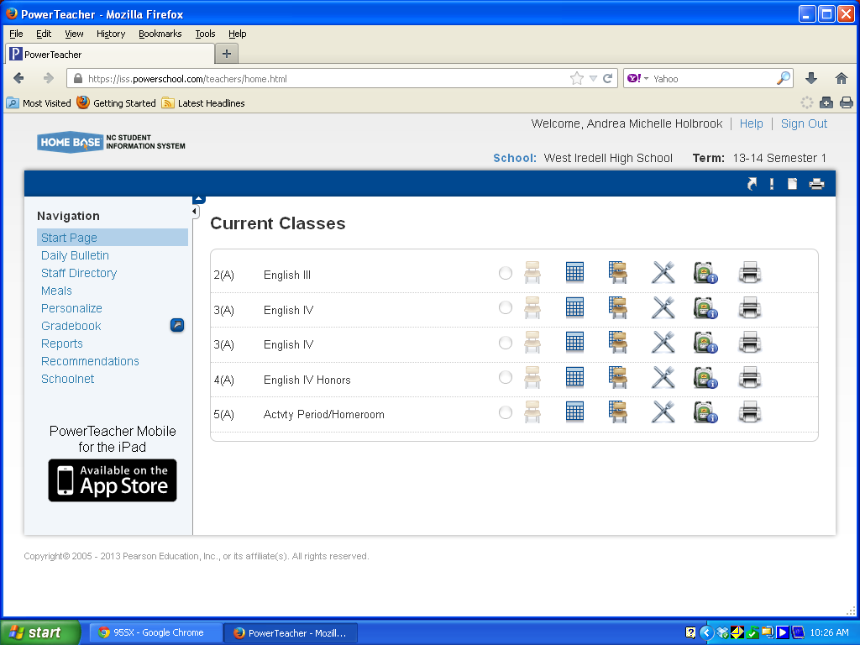
Click on the Chair or Grid to take attendance 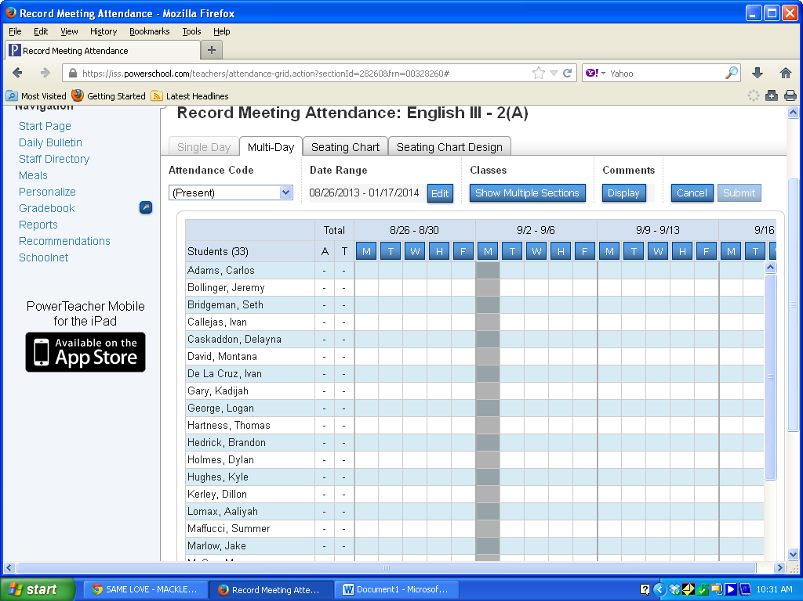
Click on the square to mark student absent (2a unexcused absence) or tardy

