The process for creating new files is the same for all file types. Watch the video below to learn more.

To create a new file:
- From Google Drive, locate and select the New button, then choose the type of file you want to create. In our example, we'll select Google Docs to create a new document.
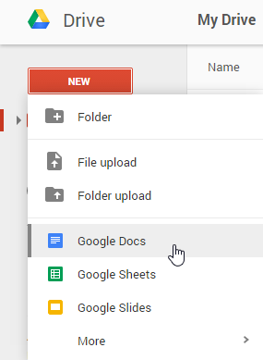
- Your new file will appear in a new tab on your browser. Locate and select Untitled document in the upper-left corner.
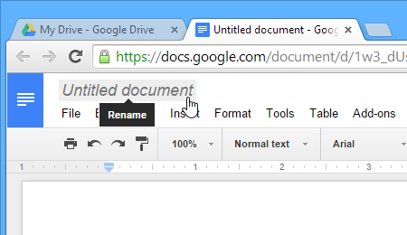
- The Rename dialog box will appear. Type a name for your file, then click OK.
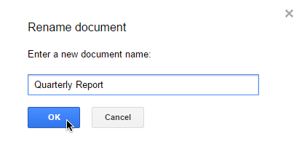
- Your file will be renamed. You can access the file at any time from your Google Drive, where it will be saved automatically. Simply double-click to open the file again.
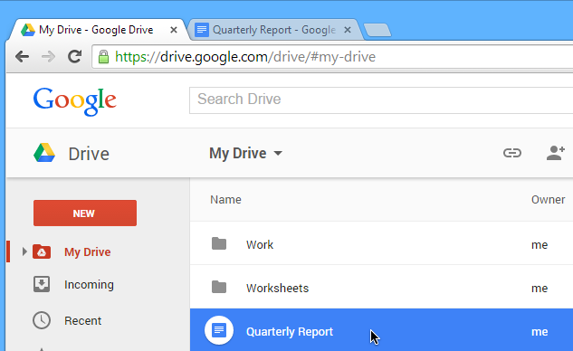
You may notice that there is no Save button for your files. This is because Google Drive uses autosave, which automatically and immediately saves your files as you edit them.
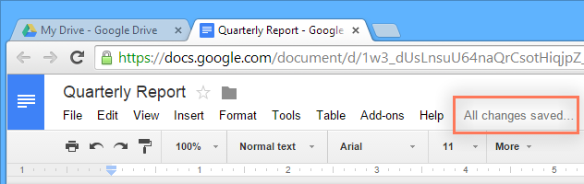

Using templates
A template is a pre-designed file you can use to quickly create new documents. Templates often include custom formatting and designs, so they can save you a lot of time and effort when starting a new project. Most templates are designed to help you create specific types of files. For instance, you could use a template to quickly create a resume or newsletter.
You can find a wide selection of templates in the Google Drive Template Gallery. Unfortunately, we've found that many of these templates aren't very well designed, and it's often difficult to find specific templates within the gallery. For this reason, we recommend using templates made by Google, which tend to be of higher quality than user-submitted templates.

To use an official Google template:
- Navigate to Templates submitted by Google.

- Several templates will appear. You can then browse templates by category or use the search bar to find something more specific.
- When you've found a template you want to use, click Use this template. You can also click Preview to view it first.
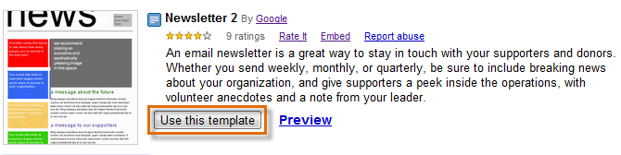
- A new file will be created with the selected template. You can then customize the file with your own information.
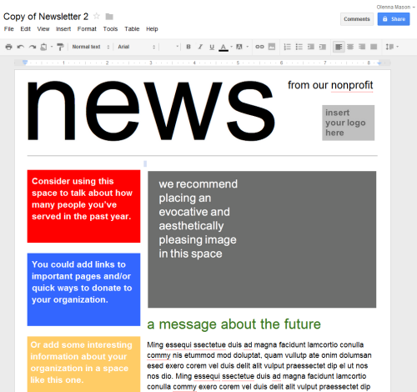

Challenge!
- Create a new file in Google Drive.
- Rename the untitled file.
- Try going back to your Google Drive to see that your new file has been added.
- Explore Google Templates.

