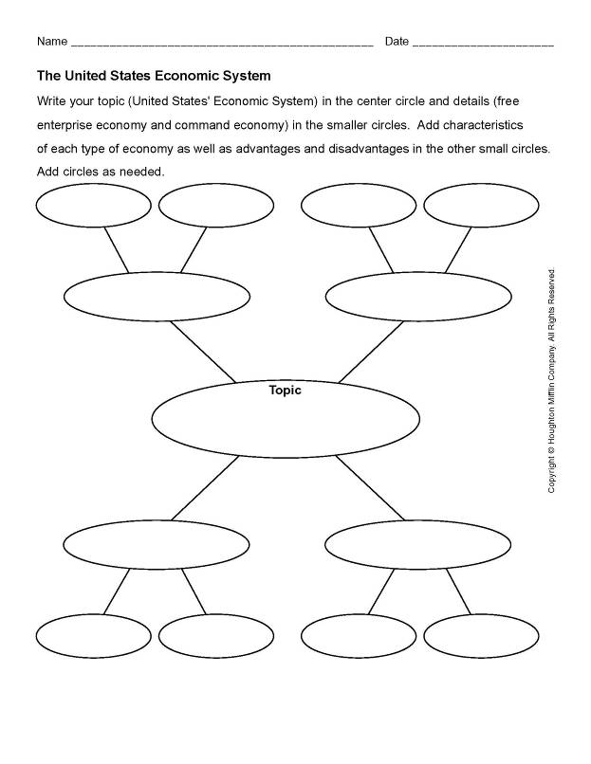
Chapter 3: US Economic System Information Worksheet
Part I
Chapter 3: US Economic System Information Worksheet
Part II

Economy

Agencies

Economy

What type of economic system does the United States (U.S.) have?

List two other countries that have a similar economic system:
_ ___________________ _______________________
List two advantages of the U.S. economic system:
_ _________ ___________________
List two disadvantages of the U.S. economic system:
_ ________
Give an example of a U.S. regulatory agency.
____________________________________________________________________
Do you think regulatory agencies are necessary? Why or why not?
____________________________________________________________________
Who or what takes care of peoples' needs in the U.S. economic system?
____________________________________________________________________
Who or what satisfies peoples' wants in the U.S. economic system?
____________________________________________________________________
List one similarity and one difference between the U.S. economy and China's economy:
_________________________ _______________________________

Chapter 4: PowerPoint Notes
Stock Market

Purpose of Stock Market

Functions of Stock Market

Impact of the Stock Market on the economy

Bull Market

Bull Market

Chapter 4 Stock Market Think Quest Guide
Instructions: Review the following websites to find out more about the stock market and to help you complete the worksheet.
http://library.thinkquest.org/3096/2types3.htm and http://library.thinkquest.org/3096/45exch.htm

\
\

