Technology can be defined many different ways by different individuals.
Yet, the tools and resources are limitless.

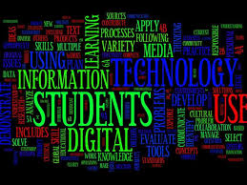
The technology education program provides experiences that lead to the development of technologically literate people. At the elementary school level, students are introduced to technology and begin learning to use it in the classroom. At the middle school level, students considering a career in technology may explore the subject in several overview courses. At the high school level, students take courses to prepare them for technical or professional programs of higher education, such as STEM careers, engineering or architecture.
Consistent with their abilities, interests, and educational needs, students completing a technology education program will achieve the following goals:

Instructional Resources
The following courses were revised for implementation during the 2015-2016 school year. All curriculum frameworks are available through VERSO from the CTE Resource Center:
    - Manufacturing Systems I, II (8425, 8427)
    - Power and Transportation (8445)
    - Technology Transfer (8405)
    - Technology Assessment (8407)
    - Advanced Drawing and Design (8438)
    - Engineering Practicum (8453)
    - Technology Education – Development (8471)
    - Technology Education – Preparation (8469)

